# What are the social outcomes of climate policies? A systematic map and synthesis of the ex-post literature.

William F. Lamb, Miklós Antal, Katharina Bohnenberger, Lina Brand, Finn Müller-Hansen, Michael Jakob, Jan C. Minx, Kilian Raiser, Benjamin K. Sovacool, Laurence Williams

## Introduction[1]

Climate mitigation policies can induce wide-ranging changes to society and everyday life. Policies that penalise fossil fuel use will often render various technologies and behaviours more expensive, or obsolete, such as private car use or coal powered electricity. Other policies that support low-carbon and low-energy innovations will give rise to an expansion of different behaviours and new technologies, such as active travel or better quality thermal insulation. The social effects of these shifts can range widely, across positive and negative dimensions: from poverty alleviation and energy affordability, to shifts in structural inequality and changes in employment opportunities. These outcomes, and how they manifest under various contexts and policies, are the subject of this review.

The climate mitigation literature is increasingly preoccupied with the social outcomes of climate policies (Barbier 2014, Bendlin 2014, Carley *et al* 2018, von Stechow *et al* 2016, Rao *et al* 2017, Klinsky and Winkler 2018, Klinsky *et al* 2016, Sovacool *et al* 2020, Lamb and Steinberger 2017). As climate policy and low-carbon energy measures start to be implemented around the world, avoiding negative social impacts has become a critical issue: if policies are perceived as unfair or socially harmful, they no doubt stand a greater chance of being attacked, repealed and revoked. This remains a deep concern in developed and developing contexts alike – including major emitting countries such as the United States, Brazil, India, France, and others – where pre-existing issues such as structural inequality and the emergence of right-wing populism have primed the political landscape against climate policy action (Lockwood 2018, Rodríguez-Pose 2018). Poorly designed policies that exacerbate social problems are a gift to fossil fuel interests, who actively exploit opportunities and alliances to prevent regulation and limit their compliance costs.

On the other hand, with sound design and governance, climate policies can undoubtedly bring positive social benefits. They could eliminate the enormous health burden of fossil combustion in cities (Kwan and Hashim 2016, Burney 2020) and address persistent fuel poverty among poor communities (Galvin 2019, Bouzarovski and Petrova 2015). They are an opportunity to initiate wide-ranging fiscal reforms, shifting funds from fossil subsidies towards directly addressing the needs of disadvantaged groups (UNEP 2018). Above all, action taken to reduce emissions now will reduce catastrophic climate impacts in the future, which will predominantly effect the global marginalised and poor (Watts *et al* 2019, Allen *et al* 2018). ‘Just transition’ proposals that forefront social benefits in climate policy design are now emerging in several countries (e.g. the “Green New Deal” in the United States) (Newell and Mulvaney 2013, Heffron and McCauley 2018). Indeed, recent analyses find that climate policies with an emphasis on fairness and equity garner more public support than those that exempt industries or place undue burdens on the poor (Maestre-Andrés *et al* 2019, Douenne and Fabre 2020, Andor *et al* 2018, Svenningsen 2019).

In this article we pose a simple question: *what are the social outcomes of climate policies?* But answering this question is not so straightforward, as this is a large subject area, with many competing frameworks and definitions regarding the ‘social’ side of climate policies (Mayrhofer and Gupta 2016, Smith and Haigler 2008). We note there is no shortage of reviews on climate policy ‘co-benefits’ (Ürge-Vorsatz *et al* 2014, Watts *et al* 2019), sustainable development linkages (von Stechow *et al* 2015), and equity considerations (Markkanen and Anger-Kraavi 2019). Indeed the topic of sustainable development and equity is addressed in chapters from the IPCC 5th Assessment Report (Fleurbaey *et al* 2014) and the Special Report on 1.5 degrees (Roy *et al* 2018).

Nevertheless, our article differs from these literatures in one crucial respect: we set out to investigate only the *ex-post* climate policy literature. This means we examine and review the social outcomes of policies in their *real implementation context*, rather than in ex-ante modelled scenarios or theoretical experiments. While there is an important role for the latter types of studies, policy making is beset by complexities of design and implementation. It takes place within an institutional and social setting – a political economy – that will no doubt influence the type and direction of social outcomes that manifest in each case. Ex-post studies that capture these details have been identified as a key gap in the climate policy literature, alongside systematic reviews that aggregate their evidence (Somanthan *et al* 2014, Minx *et al* 2017, Aldy 2014). In this sense we build upon a much smaller number of systematic reviews on climate mitigation interventions, which have to date largely focused on the health and livelihood impacts of clean cook stove and renewable energy access (Pope *et al* 2017, Policies and Operations Evaluation Department (IOB) 2013), and housing or energy efficiency measures (Thomson *et al* 2017, Maidment *et al* 2014, Camprubí *et al* 2016).

We have three broad aims in this article. First, we aim to identify the ex-post policy literature on climate change mitigation that covers social outcomes. This is not a trivial task, since such studies are by far outweighed by ex-ante modelling and scenario studies. Nonetheless, we are able to make use of innovations in machine learning, as well as extensive hand screening, to filter tens of thousands of articles and reach a high level of comprehensiveness in this task. Second, we aim to extract a variety of evidence from each study. This includes the location and type of policy; its scale and scope; and the documented climate outcomes. Most importantly for this systematic review, we extract the social outcomes from each study, including effected populations, and the type, valence and depth of each outcome. This summarised information is available in a supplementary file to this article. Finally, we aim to synthesize from the ex-post policy literature to inform and guide future policy. We examine the different types of social outcomes that resulted under varying policies and contexts. In doing so we hope to engender a new cumulative literature that learns from the ongoing implementation of climate policies.

Throughout this article we apply systematic evidence synthesis methods in order to maximise the transparency and reproducibility of our review. In other words, we use formal methods for identifying and selecting articles, and extracting and summarising information from them. In particular we apply a systematic mapping methodology, which is suited to the collation and analysis of large literatures on broad research questions (Bates *et al* 2007, James *et al* 2016, Haddaway *et al* 2016). There are very few applications of such methods in the energy social science and climate mitigation communities (Sorrell 2007, Minx *et al* 2017). As the literature rapidly expands, there is an increasing need to develop and apply such methods to avoid a host of common review biases, but still conduct these studies with sufficient speed and rigour (Westgate *et al* 2018, Haddaway and Macura 2018, Minx *et al* 2017). In this article, alongside several other contemporary publications (refs), we therefore make use of various software and machine learning tools to assist our review. We document our overall approach and methods in the following section (#2), before turning to the results (#3) and their interpretation (#4).

## Materials and methods

Systematic evidence syntheses are typically conducted in five stages (Haddaway *et al* 2018, James *et al* 2016)[2]. These include the initial scoping of a review (1), evidence searching (2), evidence screening (3), information extraction (4) and synthesis (5). Figure 1 summarises these stages. We describe them in more detail here, with additional information available in the supplementary material to this article, which includes more information on our search parameters and protocol.

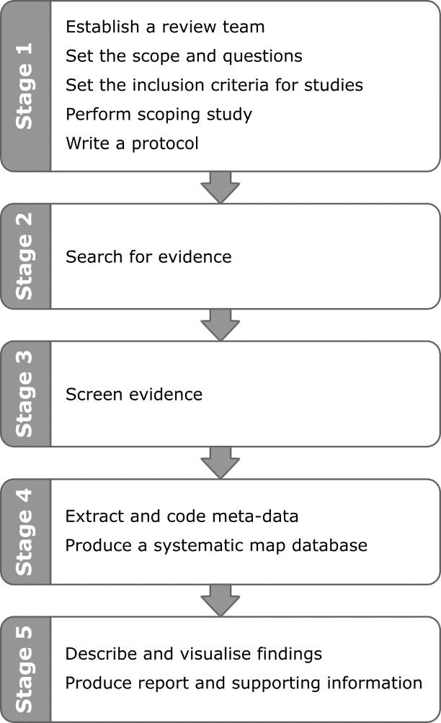

Figure 1: Stages of a systematic map

## Scope of review

Four aspects of scope determine the type of studies we review in this article: (1) the specific climate policy interventions to be investigated; (2) the scope of these policies and their targeted populations; (3) the social outcomes they induce; and (4) aspects of study and document type in each case. These respective choices are summarised in table 1 and inform the subsequent stages of article selection and screening.

***Types of climate policy interventions***. We limit our review of policy interventions to those that either penalize fossil fuel use, reduce energy demand, or support renewable energy expansion. In practice this results in an extensive list of restrictive and supportive energy sector policies, including taxes or levies on emissions, energy or fuels; feed-in-tariffs and subsidies for renewable or low-carbon energy technologies; fossil subsidy reform; emissions trading schemes; appliance standards; retrofit or renewable energy procurement obligations; information policies; direct public provisioning of renewable or low-carbon technologies and infrastructures; and moratoria or phase-outs of fossil fuels and their infrastructures.

When it comes to large-scale projects involving renewable energy deployment, in particular hydro and wind power, we find many articles documenting government interventions through planning, consent and support. We include these ‘planning’ policy interventions, so long as they refer to grid-scale (not community energy) projects, since they are often of national environmental and social significance (Castro *et al* 2016).

Certain pragmatic restrictions should be noted here. Since our review is primarily focused on energy use policies and associated sectors (electricity, mobility and industry), we do not investigate land-use policies addressing agriculture, biofuels and forestry. We also exclude policies for climate adaptation; policies that deal only with local environmental effects (e.g. local air pollution); and social policies with climate outcomes (e.g. social housing, income taxation). Finally, we do not include fuel switching policies (e.g. coal to gas, biomass to LPG) unless they were part of an explicit climate policy package. This excludes a suite of clean cook stove interventions that undoubtedly have positive climate effects and social outcomes (Cameron *et al* 2016). Nonetheless we find such measures have already been extensively reviewed in the development and health literature (Pope *et al* 2017).

***Policy scope****.* The policies we assess are implemented by national, regional or local institutions. Importantly, they must be politically mandated interventions, not the private initiatives of NGOs and companies or other sub-national actors (although these organisations and networks may be contracted to carry out a policy). This choice facilitates comparability been the diverse national contexts we study, but means we reject various NGO-led renewable technology support programs in the global South; some of which are very impressive in scope, such as the Grameen Shakti solar home system program in Bangladesh (Sovacool and Drupady 2011). It also means we exclude voluntary and community-led initiatives, on which there is a large literature, particularly in the United Kingdom (Seyfang *et al* 2013). Nonetheless, we still find that there remains a significant policy literature in the global South. For consistency, we also *include* projects run by international political institutions such as the World Bank, Asian Development Bank and United Nations agencies. Finally, we found many articles on pilot projects and short-term policy experiments; these are excluded from our scope.

***Social outcomes.*** We assess six interrelated social outcomes in this review: (1) poverty and livelihood impacts; (2) access to and affordability of electricity services; (3) the distributional impacts of policies, including income, spatial and gender inequality; (4) impacts on jobs and unemployment; (5) aspects of social and procedural justice; and (6) impacts on community cohesion and conflict. These social outcomes are leading concerns under the Sustainable Development Goals (United Nations General Assembly 2015). They have a strong theoretical foundation in eudaimonic concepts of well-being and are of the highest relevance in carrying out just climate and energy transitions (O’Neill *et al* 2018, Brand-Correa and Steinberger 2017, Lamb and Steinberger 2017).

However, several aspects of human well-being are missing from our review: health outcomes, nutrition and hunger, mobility, housing and shelter, and infrastructure access (e.g. sanitation, water). The first of these is most consequential – health being a critical component of human flourishing in most formulations of well-being (Doyal and Gough 1991, Nussbaum 2003, Sen 1999, Alkire 2002). Nonetheless, we exclude it for pragmatic reasons, due to the enormous expansion of potential literature and health related search terms to screen. Systematic reviews have already been conducted on the health effects of housing improvements and energy efficiency measures (Thomson *et al* 2017, Maidment *et al* 2014, Camprubí *et al* 2016). And while we are aware of a growing body of literature linking climate policies to social outcomes in areas such as mobility (Mattioli 2016) and infrastructure access (Jakob *et al* 2016), we exclude these on the expectation that there are few existing policies and hence few studies to review.

Finally, we do not include studies assessing aggregate measures of welfare, GDP loss and the ‘social cost of carbon’. These are important criteria for policy assessment, but are less relevant for our review of social outcomes. We follow much scholarship on the limitations of aggregate welfare measures (Costanza *et al* 2014, Stiglitz *et al* 2009) and focus our attention instead on specific social outcomes along individual, non-substitutable dimensions (Gough 2015). To be clear, this still includes studies that disaggregate income or welfare losses by income bracket or social class, as these meet the criteria of distributional analysis – the third social outcome in our review.

***Focus of study***. In this review we only include ex-post policy evaluation studies. All types of methods and approaches are acceptable. In most cases this restriction is clear, as articles often clearly indicate whether they evaluate an implemented versus a potential policy measure. A very large volume of ex-ante studies on the distributional incidence of carbon taxes is excluded by this criteria (see Ohlendorf *et al* 2018 for a meta-analysis). In some cases, authors will conduct an ex-ante analysis of policies soon to be implemented; these are also excluded from our review.

|  |  |  |
| --- | --- | --- |
| **Criteria** | **Inclusion** | **Exclusion** |
| **Climate policy intervention** | Measures that:   * Penalize fossil fuel use * Reduce energy demand * Support renewable energy expansion   This includes grid-level low-carbon energy projects (nuclear, hydro, wind, solar, biomass), which require planning, consent and support of policy makers | * Land-use sector policies (agriculture, forestry, biofuels, also migration) * Adaptation & climate impacts * Measures directed at local air pollution (e.g. NOx, SOx only) * Social policies with climate outcomes (e.g. social housing) * Energy price fluctuations with no policy intervention * Fuel switching (e.g. biomass to LPG) |
| **Policy scope** | Policies initiated by political institutions:   * National * Regional * Urban/local * International (World Bank, Asia Development Bank, UNDP) | * Policies led by private institutions, NGOs, companies * Voluntary and community initiatives, no policy involvement * Pilot studies, experiments and research-led initiatives |
| **Social outcome** | * Poverty and livelihoods * Access & affordability of electricity services * Inequality and distributional impacts (income, spatial, gender) * Jobs and unemployment * Social and procedural justice * Community cohesion and conflict * Relevant assessed populations include individuals, households, social groups (gendered, classed) | * Health, air quality * Nutrition and hunger * Infrastructure access (water, sanitation) * Mobility * Housing and shelter * Acceptability of policy/energy project * GDP, “Social cost of carbon” (aggregate economic measures without distributional analysis) * Social outcomes that relate to industries, sectors and companies alone |
| **Focus of study** | * Studies on actual implemented policies, with no method restrictions | * Studies on policies not yet implemented * Simulations of possible policies * Ex-ante analysis of implemented policies |

Table 1: Scope of systematic review and inclusion/exclusion criteria

## Evidence search

To identify articles we conduct a keyword search in the Web of Science (all collections) and SCOPUS databases. The supplementary protocol to this article documents the search string we use. It broadly comprises four combinations of keywords:

(1) Synonyms for ‘climate change’, ‘energy’, ‘fuels’, ‘renewables’ etc.

AND (2) Synonyms for ‘policies’, ‘measures’, ‘taxes’, ‘subsidies’, etc.

AND (3) Synonyms for social outcomes, such as ‘livelihoods’, ‘inequality’, ‘well-being’, etc.

AND (4) Synonyms for intervention effects, such as ‘outcomes’, ‘incidence’, ‘improvement’, etc.

This search yields approximately 60,000x articles. We reduced it to 40,000x articles using a set of generic exclusion criteria, removing all articles that are not in English; written before 1990; listed under non-relevant journal subject categories; or contain adaptation and land use synonyms in their titles (refer to the protocol for a detailed list of exclusions).

In addition to this search, we manually identify further articles based on author knowledge and from references identified while reading documents in the later stages of our review.

## Evidence screening

Evidence screening required that we examined each title and abstract yielded by our search for relevance, either including or excluding each based on the criteria set out in the scoping stage (Section 2.1; Table 1). In practice, the number of articles we yield would render this procedure enormously time consuming[3]. Therefore, instead of compromising on our broad search query, we make use of new innovations in machine learning to speed up this stage of the review.

Our screening procedure is as follows. First, we selected a *random sample* of 100 documents and independently screened it for relevance among four members of the review team. We then discussed the results and reached agreement on the appropriate scope of the review and application of the inclusion/exclusion criteria. Two further samples of 100 documents were screened by four authors in this manner, and a final 200 by the lead author alone.

Second, based on this initial set of 500 screened articles (of which 15 were relevant ex-post studies), *we applied a machine learning algorithm* to predict the relevance of all remaining documents. We use the Python Scikit learn package (Pedregosa *et al* 2011) neural network classifier to perform the machine learning. This algorithm analyses the frequency of single words (unigrams) and pairs of words (bigrams) within abstracts and titles, learning from the training set (the 500 screened articles) to predict the relevance of all remaining documents. Such machine learning tools are increasingly applied in systematic reviews to reduce the time burden (and increase the accuracy) of manually screening articles (O’Mara-Eves *et al* 2015).

Third, we *re-ordered* the remaining documents yielded by our search from highest to lowest predicted relevance. The lead author then proceeded to screen a sample of the 100 most relevant articles. On completing these, the machine learning is performed again (with the new, expanded training set), the documents are re-ordered, and a further set of articles is screened. We repeated this procedure until no further relevant articles were yielded in a sample of 100. In case certain document types or content are missing from the (progressively expanding) training set, we generated random samples of 50 documents in each iteration to screen parallel to the machine learned sample. Overall a total of 4650 documents were screened (out of x in total), yielding 381 relevant articles.

## Evidence coding

In the evidence coding stage the review team read all of the acquired articles. A set of standardised coding categories was developed to extract the relevant information from each article. This includes generic study information (location, method) and a description of the policy (e.g. the type of policy, its scope, and associated legislation and implementation date). Where possible, we extracted information on the climate outcome, such as the volume of emissions avoided or number of households treated with energy efficiency measures. Finally, we coded the social outcome, including the category of outcome (e.g. affordability, equality, employment), the affected population and the direction of the outcome (positive, negative, mixed or insignificant). A codebook in the supplementary protocol describes these categories in depth.

|  |  |  |
| --- | --- | --- |
| **Policy** | **Technology Subcategories** | **Explanation** |
| ----- Economic instruments ----- | | |
| **Tax** | Carbon, energy, fuel | A tax on CO2 emissions, fuel or energy use |
| **Feed in Tariff** | Solar, wind, other | An additional, guaranteed or regulated revenue stream provided to renewable energy producers. It is funded directly by consumers and electricity tariffs (not the government). Often issued as a price per kWh of electricity produced. |
| **Subsidy** | Solar, wind, energy efficiency, other | A subsidy/market-based support mechanism for renewable deployment or energy efficiency retrofits. Could include a rebate or tax credit to offset the cost of installation. Should not be confused with a Feed in Tariff or non-market provisioning. |
| **Subsidy removal** |  | The reform or removal of price support for energy/fossil fuels. More typical of countries in the South where such subsidies are still prevalent. |
| **Emissions trading scheme** |  | An emissions trading scheme. Notable examples in Europe (EU ETS) and California. |
| ----- Regulatory instruments ----- | | |
| **Renewable energy procurement obligation** |  | An obligation on energy companies to procure a fraction of energy from renewable sources. |
| **Energy efficiency retrofit obligation** |  | An obligation on companies, landlords and others to improve energy efficiency |
| **Appliance standards** |  | An obligation on product manufacturers to adhere to minimum standards |
| ----- Information policies ----- | | |
| **Public awareness campaigns** |  | Efforts to increase levels of climate change knowledge and concern in the public. (Unlikely to find any studies exploring social outcomes.) |
| **Labelling and certification** |  | Efforts to influence consumer choices through product labelling. (Unlikely to find any studies exploring social outcomes.) |
| ----- Planning and public provisioning ----- | | |
| **Renewable planning and deployment** |  | The grid-level deployment of renewable energy technologies. These are not strictly policies, but will at minimum they will require the consent of authorities. In large-scale examples (especially nuclear and hydro-power), governments play a strategic and driving role. |
| **Direct procurement** | Distributed renewable energy, energy efficiency retrofits | The direct provisioning of renewable energy technologies / energy efficiency retrofits by government sponsored agencies. Should be differentiated from market-based mechanisms (above). |
| **Coal phase-out** |  | The deliberate phase out of coal power stations or mines. A ban on these technologies. |

|  |  |
| --- | --- |
| **Category** | **Explanation** |
| **Access (electricity)** | Access to household electricity. |
| **Affordability (energy)** | The affordability of energy services. In the global North often referred to as "fuel poverty". It can include the affordability of both electricity and gas (for heating). |
| **Affordability (other)** | The influence of climate policies on the wider prices of goods and services in the economy, including products, rent prices, land prices, and so on. |
| **Equality (income)** | The uneven cost impacts (or benefits) of policies across income classes. Often referred to as "distributional incidence" or "distributional burdens". |
| **Equality (geographic)** | The uneven cost impacts (or benefits) of policies across geographic space. For example, between regions within a country. |
| **Equality (gender)** | The uneven cost impacts (or benefits) of policies across genders. |
| **Employment** | The impact of a climate policy on jobs and employment. |
| **Time/labour/drudgery** | The impact of a policy on everyday time use, drudgery, etc. For example, the effort required to obtain basic services such as water. |
| **Subjective well-being** | The impacts of a policy on self-reported life satisfaction or happiness |
| **Procedural justice** | The procedural implications of a climate policy: i.e. whether it appropriately consulted or involved effected communities in key decision making processes. |
| **Livelihoods and poverty** | The impacts of a policy on livelihoods and poverty |
| **Community cohesion/conflict** | The impacts of a policy on inter-/intra-community or ethnic cohesion and conflict |

Article reading and coding was performed by all co-authors. To ensure consistency between coders, we double coded a set of articles before conducting the full review […].

## Synthesis

As a final step, we conducted a two-part synthesis of the ex-post climate policy literature. First, we analysed basic information about the types of studies identified and their breakdown of assessed policies and social outcomes. In doing so we made an overall assessment of what literature exists, on which topics, using what methods. In the second part of our synthesis, we grouped the literature by policy type and investigate the social outcomes and documented in each case.

[…].

## Limitations

Despite the systematic coverage of our analysis, and our intent to be comprehensive, our study does have some notable limitations. As already indicated, our assessment of social outcomes overlooks some critical dimensions, particularly health and the mitigation of local air pollution. Positive outcomes in these dimensions may go some way towards offsetting negative effects reported for some policies – as documented, for instance, in the case of the Beijing coal phase-out policy (Barrington-Leigh *et al* 2019). It may also render some policies even more attractive, such as retrofit subsidies or procurement policies that improve thermal comfort.

Moreover, even within our systematic research design and a team of established researchers, it was not easy to decide which studies should be considered relevant for the analysis of social impacts of overarching climate legislation. One question is what qualifies as overarching legislation. The German “Energiewende” is a relatively clear example as it set long term energy policy directions with interlinked targets, approaches and policies. The other studies we included within this category were the joint analysis of multiple policies supporting renewable energy (Spain, Czech Republic) and a mix of energy efficiency measures, environmental policies and income supplements (UK). For multi-purpose legislation, it was not always clear whether they should be considered climate policies with social impacts (include) or the other way around (exclude).

Another, perhaps more difficult question is how detailed the analysis of social impacts must be for inclusion. Many articles mention some social impacts of overarching legislation – e.g. the number of jobs created in the renewables sector or effects on electricity prices – while discussing issues not relevant for our review in more detail. Furthermore, many articles give historical accounts or comment on legislation without giving detailed arguments, and often rely on other studies without performing primary analysis. We decided to only include those papers that discussed social outcomes in somewhat more detail or interpreted data from sources that did not give their own interpretations (e.g. ministries).

## Results

In this section, we present our synthetic results that get into the finer grained details about the social outcomes of climate policies. In laying out our analysis, we focus first on a general overview of the entire sample of literature before moving into a discussion of seven classes of policy: taxes, subsidies, feed-in tariffs, overarching legislation, direct procurement, grid-level planning, and other. When placing studies in these categories, our coding was inclusive, rather than mutually exclusive, meaning a single policy or study could be coded in multiple places, e.g. one that looked at taxes with FITs as part of overarching legislation. All policy categories offer case studies in the effective design of policies to capture positive social outcomes, or at least mitigate potential harms (revenue recycling, exemptions, appropriate targeting).

## An overview of the literature

As our results indicate, the ex-post literature on the social outcomes of climate policies is dominated by one journal, *Energy Policy*, rather than more climate focused journals such as *Climate Policy* or *Climatic Change*. Although studies utilized a mix of qualitative and quantitative methods, interviews and literature reviews were the most frequently employed research designs. Methods also tended to be split by research topic/social outcome: distributional analysis and employment were largely treated with statistical approaches, whereas livelihoods and justice concerns were treated with mostly qualitative approaches. Interestingly, there was not a uniform increase in literature year to year, it instead peaked within our sample in 2016, declining thereafter—perhaps being significantly shaped by the IPCC AR5, published in 2014.

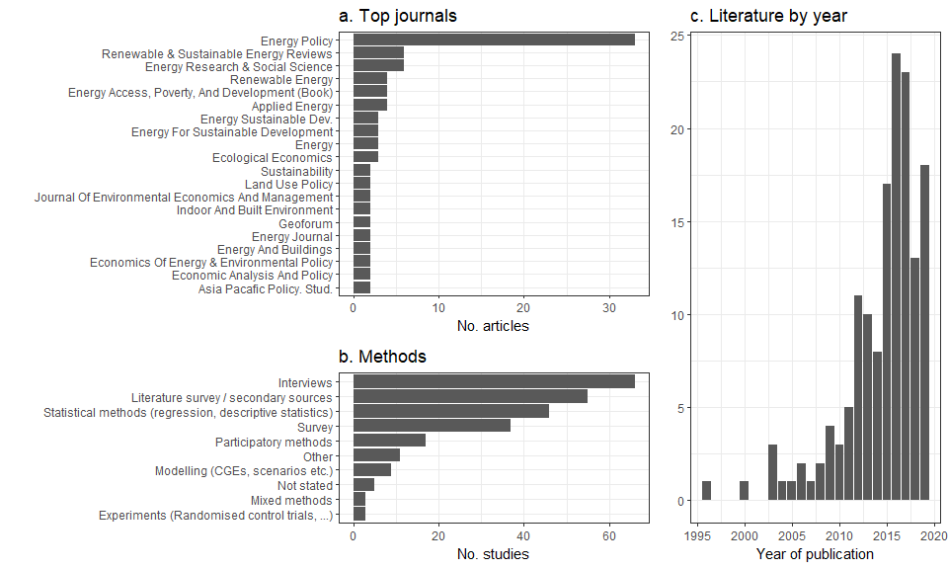

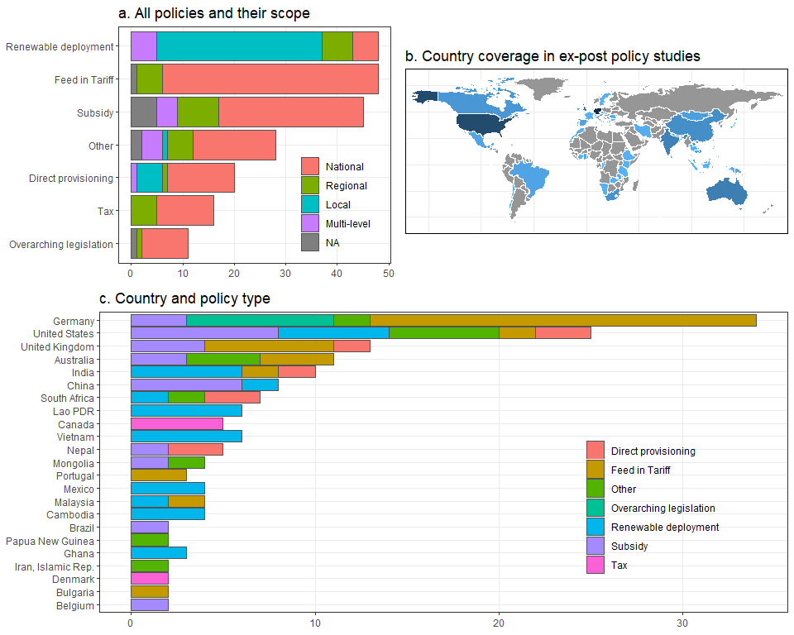

In terms of their geographic coverage, many studies are concentrated in Germany, US, UK. Of these, FiTs and subsidies are well-researched. Nonetheless, there is global coverage in the literature, due to many local case studies of renewable planning and deployment in the global South, although major gaps exist, for example in Russia, Latin America, Central Asia and North Africa.

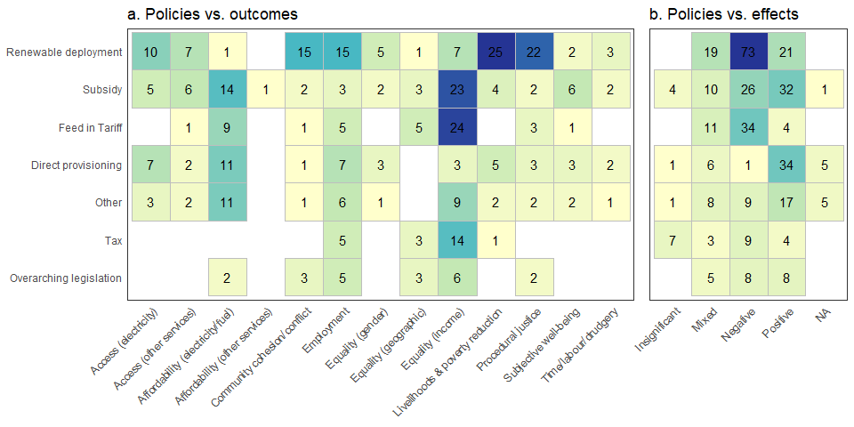

The literature is further divided in the type of social outcomes investigated in each policy category. Economic effects such as distributional outcomes (income), fuel/electricity affordability and employment are the focus of studies on subsidies, feed in tariffs and taxes. Renewable deployment studies have tended to focus on livelihoods and poverty, procedural justice and community cohesion. Substantively, there is a rather negative overall assessment for renewable deployment and feed in tariffs from a social standpoint in terms of those mechanisms failing to reduce poverty, but there is a general positive trend for direct procurement linking to social outcomes.

|  |  |  |  |  |
| --- | --- | --- | --- | --- |
| Jurisdiction | Policy | Policy category | Description of scale or scope | References |
| United States of America | U.S. Weatherization Assistance Program |  |  |  |
| United Kingdom | Warm Front Home Energy Efficiency Program | Subsidy (energy efficiency retrofits) |  |  |
| Germany | EEG | FiT, legislation |  |  |
|  |  |  |  |  |

Table : Large-scale policies in the reviewed literature

There are clear differences in the study sample with regards policy ambition. Of course, it is difficult to compare policy scale and scope, this being reported variously as the number of households treated (common for retrofit programs), emissions avoided (often reported in modelling studies), installed capacity, or total program programme spend (relevant for subsidies). Table 2 reports some particularly large scale policies reviewed in the literature.

## Climate policies and their social outcomes

## Taxes

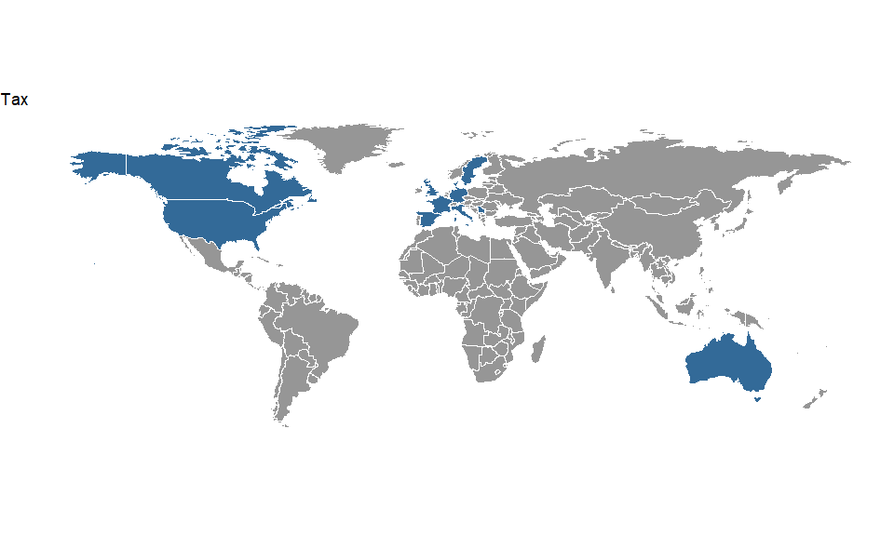

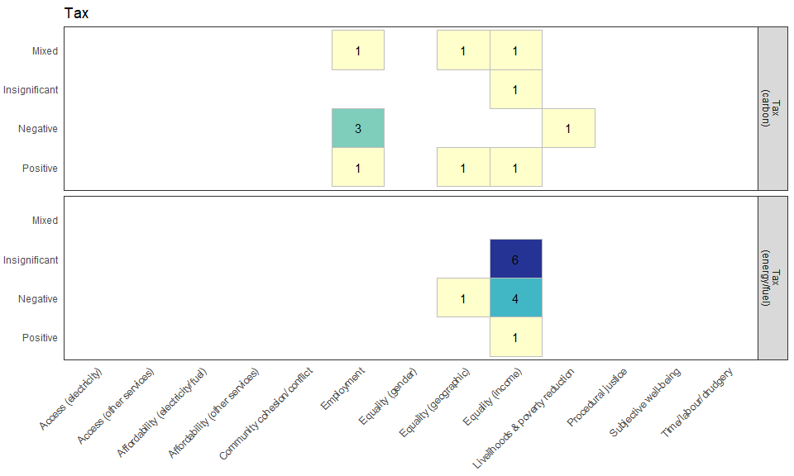

*Overview*

Ex-post evaluations of the social outcomes of tax policies are restricted to experiences from industrialized countries. Of the ten studies assessed, seven analyse the effects of carbon taxes, one taxes on gasoline and diesel, and two a broad array of environmental taxes. The earliest indicated start date for any of these policies is 1993, even though it seems safe to assume that taxes for transport fuels have been in place for much longer.

In most cases, these studies do not explicitly account for the climate effects of the policies under scrutiny. Two studies present quantitative estimates of implied emission reductions, and one study argues that the analysed fuel taxes would reduce emissions, but does not provide a quantitative assessment.

*Distributional outcomes*

In terms of social outcomes, the large majority of studies focus on the distributional outcomes of environmental taxes. One study (Sterner, ref) builds on household surveys to compare the incidence of taxes on transport fuels (gasoline and diesel) for seven European countries, namely France, Germany, Italy, Serbia, Sweden, Spain and the UK. The results indicate that on average, these taxes are slightly regressive, but that the effect is so small that they can be considered to be roughly neutral, i.e. impose a similar burden on poor and rich households relative to their income. Considering expenditures as a proxy of lifetime income instead of available actual income yields neutral outcomes (weakly progressive in some countries, and weakly regressive in others).

Two studies analysing the effects of a broad basket of environmental taxes (including transport fuels and CO2) on household income in Denmark (Jacobsen et al., Wier et al.) both find overall regressive effects (again, using expenditures instead of disposable income results in less regressive effects) and a higher cost burden for rural than for urban households. In addition, Jacobsen et al. highlight that the Danish tax on transport fuels is progressive, and Wier et al. show that indirect effects of environmental taxes are taken into account, the rural population is only slightly more affected than the urban one.

All three studies examining the distributional effects of the British Columbia carbon tax find progressive distributional effects, which are attributed to the recycling of revenues by means of overall tax reductions and transfers to particularly affected households (Beck and Rivers, Beck et al., Murray et al.). Even though further scaling up of the tax in later years without increasing support for low-income households may have resulted in regressive outcomes, the overall effect is assumed to be small (Murray et al.). Furthermore, without compensatory measures, this carbon tax would have had the most severe adverse impacts for the rural population. With revenue recycling, however, it conveys a welfare gain to rural households, even though to a lesser extent than for urban dwellers (Beck et al.).

Finally, one study comparing the effects of the US gasoline tax across social groups for different indicators (income, expenditures and wealth-adjusted income) finds regressive distributional outcomes for almost all constellations.

To sum up, the available literature presents mixed results on the distributional effects of carbon and fuel taxes. These differences can be attributed to country-specific differences, the type of policy under study (carbon tax vs. fuel tax) as well as the type of indicator used (actual income vs. expenditures, which is sometimes used as a proxy for lifetime income). Moreover, revenue recycling, which is only considered for the studies for British Columbia, is a key determinant of distributional consequences.

*Employment effects*

Both studies that examine the effects of carbon pricing on employment have been undertaken for the Canadian province of British Columbia. The two studies, which take different methodological approaches, find contradictory results. Using a partial equilibrium model and an empirical demand function for labor based on industry-level employment data, Yamazaki (2015) finds positive overall labor market effects, in spite of negative effects for emission-intensive and trade-exposed (EITE) sectors. By contrast, Yip (2018) carries out an analysis based on individual-level data on unemployment, labor force participation, and the natures of layoffs and new hires. His results indicate that the carbon tax has reduced employment, in particular for medium- and low-educated males.

*Poverty alleviation*

One study examining the effect of the carbon tax on housing affordability in Australia (Ge) finds that especially low-income households have been adversely affected, mainly by higher gas and electricity prices.

## Subsidies

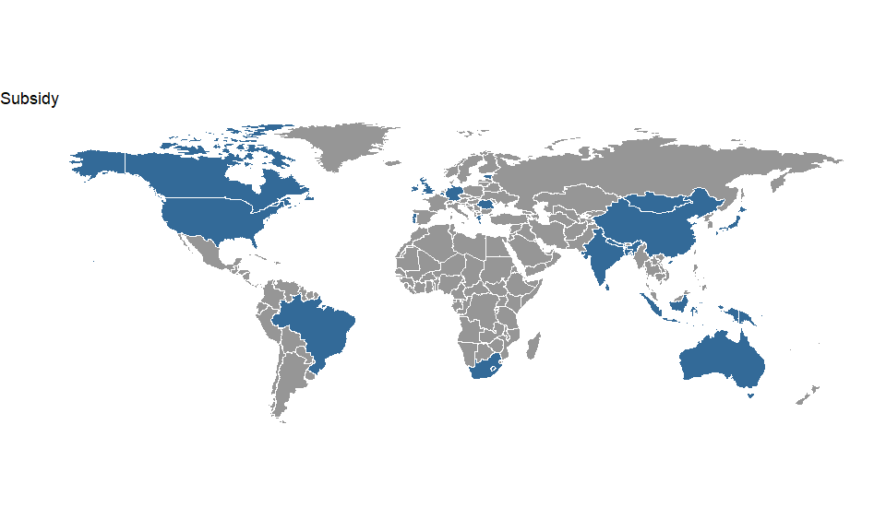

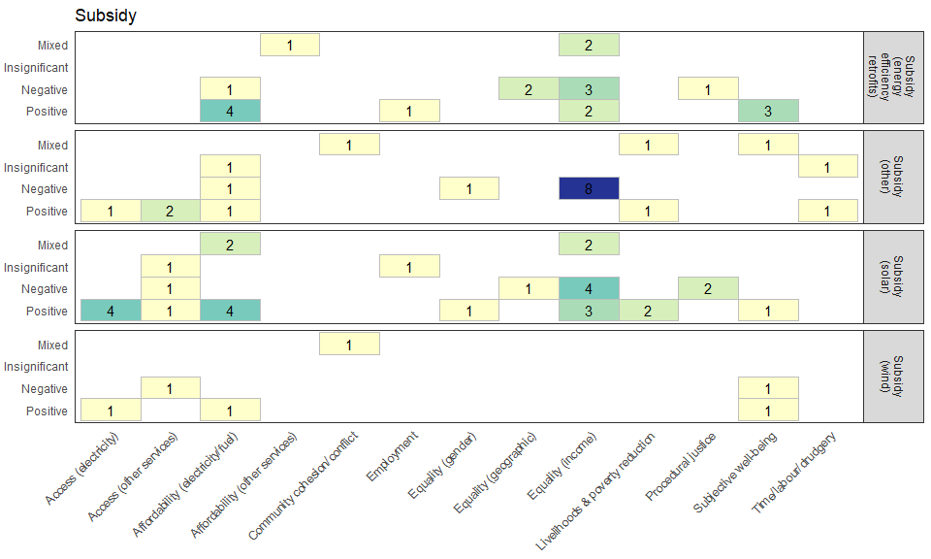

Overview

Compared with taxes, ex-post evaluations of subsidy schemes are both greater in number and broader in their coverage of social outcomes and geographies. Overall, we find XXX studies reporting on YYY individual subsidy schemes. Subsidy schemes are provided in support for energy efficiency retrofits (12 studies – all REFs?), solar installations (12 studies – all refs?), and other (11 studies a- all refs?) including wind power, biogas, green electricity or clean energy investments in general. The time coverage of subsidy schemes analysed starts from XXX, but is mainly clustered around YYY.

Geographically, we find cases across all continents covering a total of 21 countries. (county by continents; numbers by countries). While X studies are focussed at the national level, there are 13 sub-national cases (incl. Wales – which technically is a devolved country) of which 7 also involve analysis at the city level. Sub-national cases in the sample exclusively cover Europe, U.S., India and China.

A suite of different methods are used to analyse social outcomes of subsidy schemes: fifteen studies apply statistical methods, thirteen conduct interviews and nine involve a literature review element. Other methods are much less frequently applied and involve a survey (4), a mixed method approach (2), an experiment (2) as well as participatory methods and CGE modelling.

Finally, across the different policy instrument the literature on subsidy schemes covers the broadest range of social outcomes. While analyses of social outcomes most frequently focus on analysing the effects on income distribution (19), there are also clusters of studies examining the impacts on affordability of electricity (9), service access (9) as well as subjective well-being. There are at most two studies providing evidence for the other social outcomes. The balance of evidence in terms of the quality of the outcome effect is mixed: we find 27 positive outcomes reported and 35 negative ones, while 11 studies show mixed positive and negative results.

*Subsidies for solar installations*

There are twelve studies in our final sample analysing the social outcomes of subsidy schemes for solar installations covering both developing countries such as Bangladesh, Nepal or Indonesia as well as developed countries such as Australia, Germany, and the United States. For developing countries social outcome evaluation of subsidy schemes for solar installations find exclusively positive effects, while the picture is very mixed for developed countries. Similarly, studies find across the board mainly positive effects of subsidies for solar installations in terms of affordability and service access while the picture is much more mixed for equity and equality issues as well as poverty reduction.

In terms of the developing country clusters, Bhattarai et al. (2018) use statistical methods to analyse participation in a Nepalese subsidy scheme for solar home systems and find that it is accessible to the poor. Of the 27% of eligible households that participated in the scheme, 25% were below the poverty line compared to a poverty rate of 19% in the country. Still across the sample, poorer households are 18 percentage points less likely to adopt solar home systems than richer households. Despite limited reach of the Indonesian programme, Sovacool (2012a) reports from interviews on the satisfaction of participants with solar home installations due to the relative affordability compared to fossil-fuel based alternatives such as kerosene or diesel, but also their income generating potential. From a similar interview-based assessment of China’s renewable energy development project to improve uptake of solar heating units in off-grid rural areas, Sovacool (2012b) finds positive income effects, improved access to modern energy services as well as better affordability of renewable energy services for rural households. Finally, Kabir et al. (2010) look at the role of microfinance in developing sustainable energy management in remote communities of Bangladesh reporting positive effects for rural electrification, poverty reduction, service access as well as gender. [add only one study also looks at climate outcomes – driven by development concerns]

With developed countries’ focus on combating climate change, case studies typically report not only on social but also climate outcomes. Two studies assess the Photovoltaic Rebate Programme in Australia taking place between 2000 and 2010 triggering a total of about 110,000 PV installations (128MW) at an estimated cost of about 1.1 billion Australian dollars (Granquist and Grover, 2016). Macintosh and Wilkinson (2011) highlight the lack of environmental as well as cost effectiveness of the programme with estimated emission savings of 0.1 MtCO2eq/yr and abatement costs ranging between AU$238 and AU$282 per tonne of GHG emission reduction. In terms of fairness, adoption of the schemes was skewed towards households in wealthy post-code areas benefited from the rebate even though this effect decreased over the lifetime of the programme. Granqvist and Grover (2016) focus on the assessment of various fairness aspects and find two of their three criteria (proportional payments; protection of lowest welfare levels) fulfilled. For the 100,000 rooftop programme initiated by the German government to install 300MW photovoltaic installations between 1999-2003, Reichmuth und Hünnekes (2003) report mixed effects for affordability (as break-even costs is only reached for goods sites with high irradiation), but positive employment effects. Vaishnav et al. (2017) assess place-specific costs and benefits of the 540,000 installed systems (6GW capacity) in the US and find that public benefits exceed the subsidies paid to owners only for 10% of the installation. In distributional terms wealthier counties benefited more from subsidies even though the effect decreased over time. Another US study (Nicols and Greschner, 2013) focusses on programmes aimed at increasing solar penetration in low-income communities finding positive effects in terms of poverty reduction and income distribution from energy expense savings of about $350-500 per year. Fraser and Chapman (2018) report negative social impacts from mega-solar plants in Japan and a lack of positive impacts on employment and municipal income. Finally, in a comparative study between Belgium and Portugal Bartiaux et al. (2016) point out that solar subsidies did not adequately reach lower and middle class and as such further increased inequalities in both places.

Between X-Y the programme did Z.

## Feed in tariffs

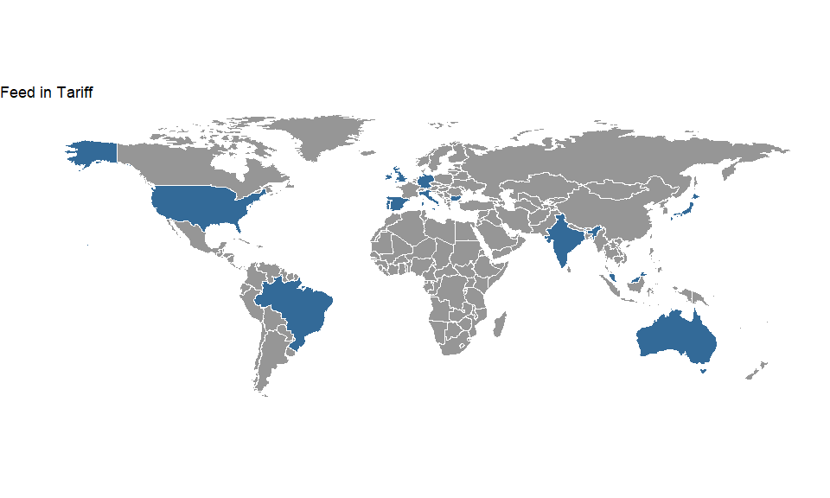

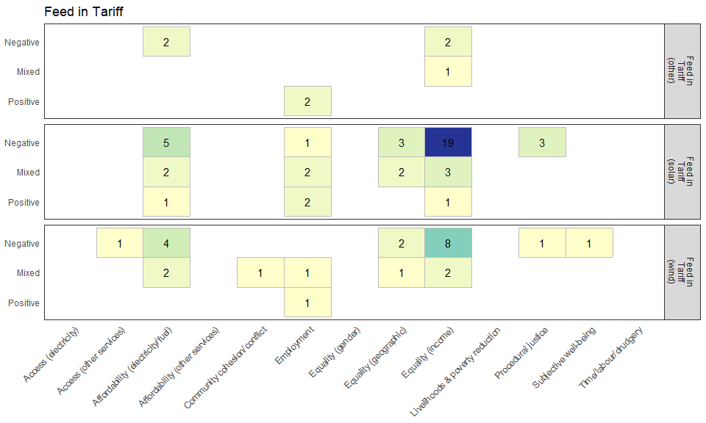

*Overview*

We identified a similarly large sample, 32 studies, on social outcomes of feed-in tariff (FIT) systems. The majority of studies investigate policies for solar energy (29). 13 studies cover systems for wind and five studies also look at FITs for other renewable energies. Some of the studies look at systems that are applicable to several renewable energy technologies (8 studies), sometimes also in combination with other policy instruments like subsidies (3), grid-level renewable deployment schemes (2) or renewable energy procurement obligations (2).

The identified studies mainly investigate social outcomes in industrialized countries. Most studies focus on Germany (9), the UK (5), or Australia (4) while there are only four on other European countries (4), two on the US and one on Japan (Chapman and Fraser, 2019). Only three studies investigate FIT systems in countries of the Global South: India (Yenneti et al., 2015; 2016) and Malaysia (Muhammad-Sukki et al., 2014). While most of the investigated FITs are national policies, five papers cover regional policies in Hawaii (Coffman et al., 2016), California (Grandqvist and Grover, 2016), Australia (Nelson et al., 2011; Chapman et al., 2016) and India (Yenneti et al., 2016). The earliest FITs evaluated in one of the surveyed studies dates back to 1998 in Spain (de Miera et al., 2008), but most of the policies were established in the 2000s. The latest policies in our sample were established in 2011 in Malaysia (Muhammad-Sukki et al., 2014) and in 2012 in Japan (Chapman and Fraser, 2018).

Most studies report the renewable energy deployment induced by the FITs, with scales from a few metawatts to dozens of gigawatts of installed capacity or more than a million individually installed roof-top PV systems (Poruschi and Ambrey, 2019). Some studies also calculate the avoided emissions corresponding to the replacement of power in the average electricity mix. Overall, FIT systems have been very successful in expanding renewable energies in many countries.

The majority of studies used statistical methods to assess social outcomes (15), although many also used secondary sources, especially the academic and policy literature, to substantiate their claims (9). Some studies used mainly qualitative techniques like interviews (5) and surveys (Chapman and Fraser, 2019) and three studies applied computational modelling.

*Social outcomes*

Most studies of social outcomes of FITs evaluate distributional aspects, especially effects on disposable income. Five studies report decreasing affordability of electricity and a majority of 19 studies finds that solar FIT policies exacerbate income inequality. The main reason for decreasing affordability is that most FIT systems are financed through a levy on the electric energy that is charged on electricity consumers, leading to increasing wholesale prices (Andreas et al., 2018; Behrens et al., 2016; Frondel et al., 2008, 2010, 2015).

One of the main reasons for the regressive effects on disposable income is that low-income households on average spend a higher share of their income on electricity. Therefore, they are affected disproportionally by higher electricity wholesale prices (e.g. Frondel et al., 2015; Verde ). In Germany, the levy increased further because of extensive exemptions for energy-intensive industries (Neuhoff et al., 2013). However, the increased share of renewables also led to decreasing spot market prices of electricity due to the merit-order effect, which made the policy less regressive (Cludius et al., 2014).

While all electricity consuming households are affected by higher costs, only those that can afford investments in renewable energy gain monetary profits from the policy. This is especially important for FIT schemes that promote residential and roof-top PV systems. Owners of PV systems often belong to high-income groups. These groups therefore disproportionally profit from FITs (Andor et al., 2015, Nelson et al., 2011; Coffman et al., 2016; Grover and Deniels, 2017). Feed-in-policies can furthermore increase distribution charges, either directly because PV integration increases grid costs, or indirectly because owners of PV systems can consume their own electricity thereby reducing the base over which the total grid costs can be shared (Strielkowski et al., 2017). All these mechanisms can make the policy’s regressive distributional effects stronger.

But there are also four studies that find positive or mixed effects on equality and affordability at different levels: California’s FIT “explicitly supports low- and very low-income households” (Grandqvist and Grover, 2016). Local energy organisations can help low-income people to profit from FIT systems, as case studies by Saunders et al. (2011) show. In local Japanese communities, indicators of social equity improved with the siting of mega-solar plants (Chapman and Fraser, 2018). Finally, De Miera et al. (2008) demonstrate that savings due to the merit-order effect outweighed the costs of the FITs in Spain.

FIT policies do not only affect income, but also geographic inequalities: PV installations are sparser in denser urban environments in Australia, suggesting that renters are profiting much less (Poruschi and Ambrey, 2019). And while PV installations in the UK are more concentrated in high-income areas, wind projects are mainly realized in medium-income areas (Leicester et al., 2011).

Two cases highlight procedural injustice as a problem with FIT policies. First, the low requirements of Indian FIT systems are a reason for the lack of information exchange and representation of the local communities in project planning, as a case study of a mega-solar project in rural India showed (Yenneti et al. 2015, 2016). Second, under the Bulgarian FIT, government decisions for energy projects lack transparency and public consultations, furthering corruption between politicians and investors (Andreas et al., 2018).

The only social outcome of FITs that was mainly positively evaluated is the effect on employment: The policies in Malaysia and Portugal led to net job creation (Muhammad-Sukki et al., 2014, Behrens et al., 2016), while for Germany two studies found mixed evidence (Pahle et al., 2016; Frondel et al. 2010) and one negative effects (Frondel et al., 2008).

In summary, FITs have two specific distributional effects, on which the literature mostly agrees: First, the costs of increasing renewables in the power system is shared based on electricity consumption, which makes it regressive. Second, the profiteers of FITs for residential PV systems are homeowners who can afford these investments. But there are remedies: Exemptions for low-income households or less reductions for energy-intensive industries can make the levy less regressive. Furthermore, local energy communities and targeted financial programs can facilitate access to renewable energy systems such that low-income households can also profit from FITs. The other social outcomes discussed in relation to FITs are not specific to the policy instruments: procedural injustice is also a problem for other energy policies in countries with poor or top-down governance structures and other renewable support schemes can have similar effects on employment.

## Overarching legislation

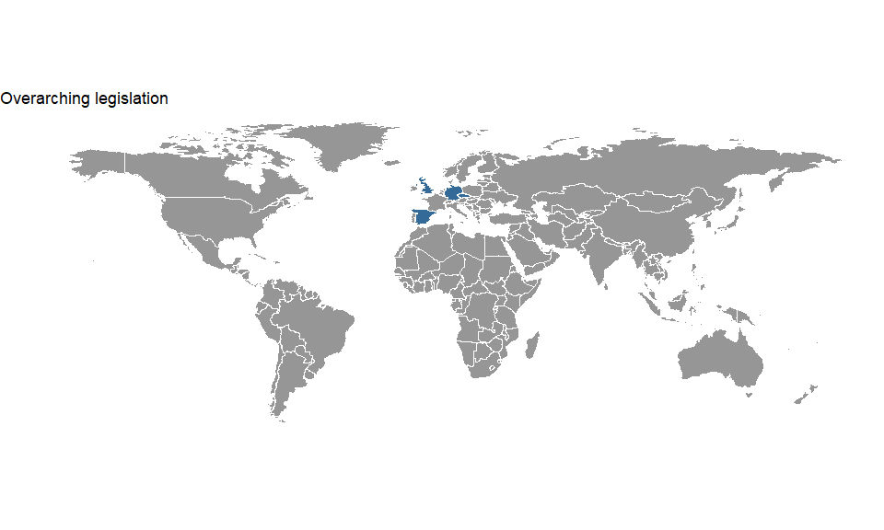

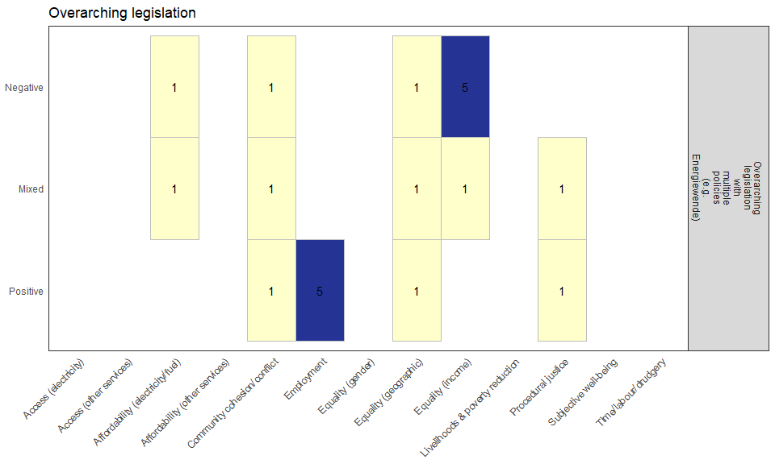

A total of 11 papers investigated overarching legislation, by which we mean KOKO: eight on the German Energiewende focusing on the post-2000 period, one on a Spanish region (Navarre, 1995-2002), one on the Czech Republic (2008-2013) and one on the UK (2000-2011). Climate outcomes in these papers are usually discussed in terms of the growing shares of renewable energy. The social impacts that are most frequently covered are equality (6 papers, negative for income inequality and mixed for geographical inequality), employment (6 papers, mostly positive), affordability (2 papers, mixed/negative), and community coherence (2 papers, mixed/positive).

The articles on Germany using statistical methods find that the electricity surcharge from which the transition is financed has a regressive distributional effect (Többen, 2017; Winter and Schlesewsky, 2019), mainly because the surcharge constitutes a constant share of the electricity price and energy costs have a higher share in the budgets of poor households. This has a negative impact on the affordability of energy (Sopher, 2015). To make things worse, rich households profit more from subsidies to rooftop solar (Winter and Schlesewsky, 2019) and network charges further increase income inequality, not least because lower population density correlates with lower incomes but higher grid costs (Schelesewsky and Winter, 2018). In terms of geographical equality, results are mixed: the largest negative impacts fall on relatively rich city states (Többen, 2017), but solar subsidies mainly go to the relatively rich South (Winter and Schlesewsky, 2019). However, Gawel et al. (2015) warn that it is impossible to make general statements about the distributional effects of the Energiewende based on a mere assessment of surcharge payments and subsidies. Other costs and benefits, including externalities, have to be considered, and the baseline for any comparison has to be clarified because no alternative would be neutral from a distributional perspective.

Still in Germany, employment effects are found to be positive (Sopher, 2015; Kannen, 2017), especially for Eastern federal states where unemployment is higher (Pegels, 2014). For communities and procedural justice, a complex process like the Energiewende has complex effects: community-based renewables are often evaluated positively, but old industrial communities often lose out (Kannen, 2017; Morton and Müller, 2016). Citizen participation is usually perceived as very beneficial, but people see different threats to their communities and if someone’s perspective is sidelined, then it is easy to feel excluded (Morton and Müller, 2016).

Like in Germany, job creation has been found to be an important benefit of overarching climate legislation in Spain (Faulin et al., 2006) and the Czech Republic (Dvořák, 2017). At a regional scale, positive economic effects have been most pronounced for wind in Navarre, Spain, and for biomass and biofuels in the peripheral parts of the Czech Republic. Benefits were found to be dependent on continued financial incentives and institutional support.

Like several papers on the Energiewende, the article on the UK policies – six different energy saving, renewable energy and emission reduction policies supplemented by payments and discounts for the poor – also looked at distributional impacts and found negative impacts (Chawla and Pollitt, 2013). Imperfect targeting of low-income households was the main reasons for this. Yet income supplements could likely ensure that the poorest people were not adversely affected by the policies.

## Direct procurement

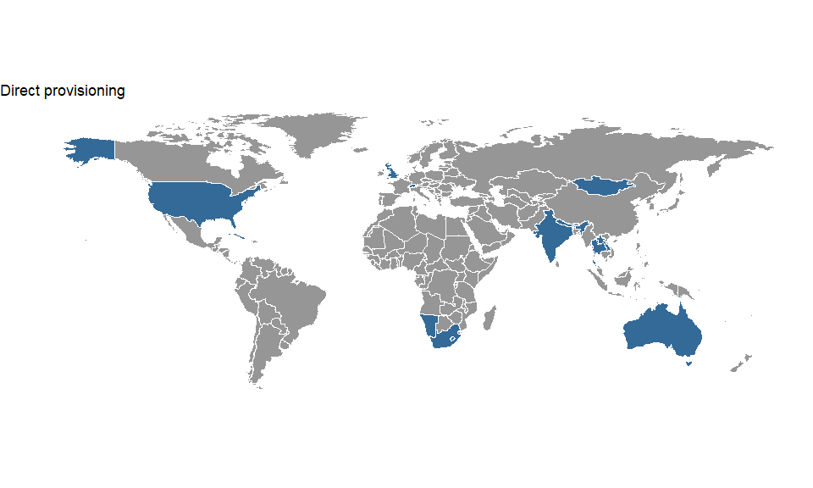

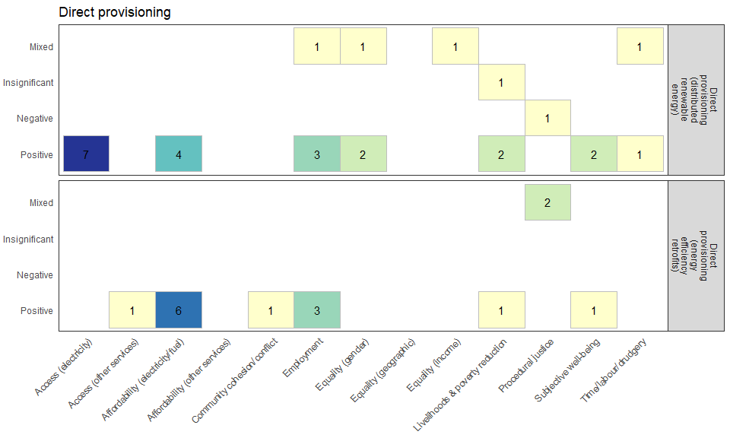

*Overview*

We identified 15 ex-post evaluations of the social outcomes of direct procurement policies covering 10 different policies world-wide (two policies are covered by multiple papers). 5 policies focus on the direct provision of renewably energy including small scale hydropower units in Nepal (Mahat 2011, 2006, Sovacool 2016), solar water heaters in South Africa (Curry *et al* 2017), hybrid solar-diesel mini-grids in Namibia (Azimoh *et al* 2017), biogas units in India (Raha *et al* 2014), and micro-hydro and solar panels in Cuba (Cherni and Hill 2009). The other 5 policies studied were energy retrofit programs including the Weatherization Assistance Program in the US (Schweitzer and Tonn 2003, Tonn *et al* 2003, Riggert *et al* 2000), two retrofit programs in the UK (Grey *et al* 2017, Shortt and Rugkåsa 2007), and one each in Switzerland (Yushchenko and Patel 2016) and Australia (Watson *et al* 2015). Geographically there is a discernible divide with all renewable energy policies located within developing/emerging economies, whereas all 5 energy retrofit programs were located in industrialized countries. Moreover, the renewable energy programs were predominantly national in scale, with the exception of Azimoh et al’s study of the installation of a hybrid mini-grid in Twumkwe Village in Namibia (Azimoh *et al* 2017). Conversely the energy retrofit policies studied were more varied with the Weatherization Assistance Program retaining a national focus whereas the other 4 policies studied were more locally/regionally focused. Apart from the Weatherization Assistance Program which was started in 1976, the other policies studied were generally initiated around the early 2000’s, ranging from the Renewable Energy Development Program in Nepal, initiated in 1996, to the Get Smart Bill in Tasmania, Australia in 2013.

*Climate Outcomes*

12 of the 15 studies identified reported the climate outcome of the polices under scrutiny. All but one study on renewable energy deployment reports a climate outcome, with most focusing on the level of energy deployment reporting from 51,900 installed solar heater systems in Thailand (Green 2004, p 749), the installation of 6MW of micro-hydro systems in Nepal (Sovacool 2016), and the construction of 200 hydroelectric plants in Cuba (Cherni and Hill 2009). One study reporting energy efficiency improvements of 7.7GWh/y in due to solar water heater installations in South Africa (Curry *et al* 2017). The studies on efficiency retrofit provided statistics on the number of households retrofitted, ranging from 54 in Northern Ireland (Shortt and Rugkåsa 2007) to 5 Million through the Weatherization program in the US (Schweitzer and Tonn 2003, Tonn *et al* 2003). They also reported a 0.1% reduction in the total amount of energy consumed in the Genevan canton (Yushchenko and Patel 2016). Finally, Riggert et al. also provide info on CO2 emissions avoided, amounting to 121-2,145 (pounds per MMBTU) (Riggert *et al* 2000).

*Social Outcomes*

The studies reported primarily positive social outcomes, with only a single negative finding (there were however 6 mixed findings and one insignificant). Both the literatures studying renewable energy provisioning and energy efficiency retrofits cite the affordability of electricity as a positive social outcome (Raha *et al* 2014, Curry *et al* 2017, Shortt and Rugkåsa 2007, Schweitzer and Tonn 2003, Tonn *et al* 2003, Grey *et al* 2017). While the studies covering renewable energy deployment also report electricity access (Mahat 2006, Sovacool 2016, Azimoh *et al* 2017, Green 2004) and poverty reduction (Green 2004, Cherni and Hill 2009, Sovacool 2016) as significant and recurring positive outcomes, the literature on energy efficiency retrofits instead identifies employment as an additional positive outcome (Yushchenko and Patel 2016, Riggert *et al* 2000, Schweitzer and Tonn 2003).

Further identified positive outcomes include income equality (Riggert *et al* 2000), subjective well-being (Azimoh *et al* 2017, Grey *et al* 2017), community cohesion (Riggert *et al* 2000), gender equality (Sovacool and Linnér 2016), time/labour/drudgery (Curry *et al* 2017), procedural justice (Grey *et al* 2017), and access to other services (Grey *et al* 2017). Mixed outcomes include gender equality (Mahat 2011), procedural justice (Watson *et al* 2015), employment (Cherni and Hill 2009), time/labour/drudgery (Mahat 2006), income equality (Sovacool 2016), and procedural justice (Grey *et al* 2017). One study noted procedural justice as a negative outcome (Mahat 2006).

As is evident above, both the provision of renewable energy and energy efficiency retrofits are associated with a broad and varied group of positive social outcomes. Key here is affordability, with direct provisioning of these technologies providing the beneficiaries of the policies with cheaper electricity or energy bills regardless of the context within which they are implemented. For the studied renewable energy deployment policies, which were all situated in developing/emerging economies, access to electricity and poverty reduction were further important social outcomes. In contrast, the studies of energy efficiency retrofit programs in industrialized economies reported the employment opportunities created by each policy as a significant social outcomes. Poverty reduction was also cited as a positive outcome of the Weatherization Accessibility Program in the US (Schweitzer and Tonn 2003) and though not explicitly reported as such, increased employment combined with cheaper energy bills are also likely to alleviate poverty levels. Moreover employment was also cited as a positive outcome of renewable energy deployment in South Africa (Curry *et al* 2017).

Both Sovacool and Mahat find that the positive impact of the REDP in Nepal on gender and income equality was mediated somewhat by pre-existing inequalities both in terms of gender, with men generally retaining ownership over installed renewable energy systems, and income, with established caste systems leading to non-uniform pricing and access to renewable energy (Mahat 2006, Sovacool 2016). Some studies identified further mediators of positive outcomes, arguing for example that poverty alleviation would be better served by efforts to increase income than to deploy houses with energy efficiency retrofits (Shortt and Rugkåsa 2007). Further issues include a lack of maintenance of installed renewable energy units (Raha *et al* 2014, Curry *et al* 2017). Finally, however, the integration of communities, of social goals, and of other policies was frequently cited as a supporting factor in a number of studies (Azimoh *et al* 2017, Cherni and Hill 2009, Grey *et al* 2017).

In conclusion direct procurement seems to be a climate policy with significant positive social outcomes. Depending on the context of the policies a range of social outcomes has been reported, with affordability of, and access to, electricity/energy as well as employment and poverty reduction standing out as primary positives.

## Renewable planning and deployment

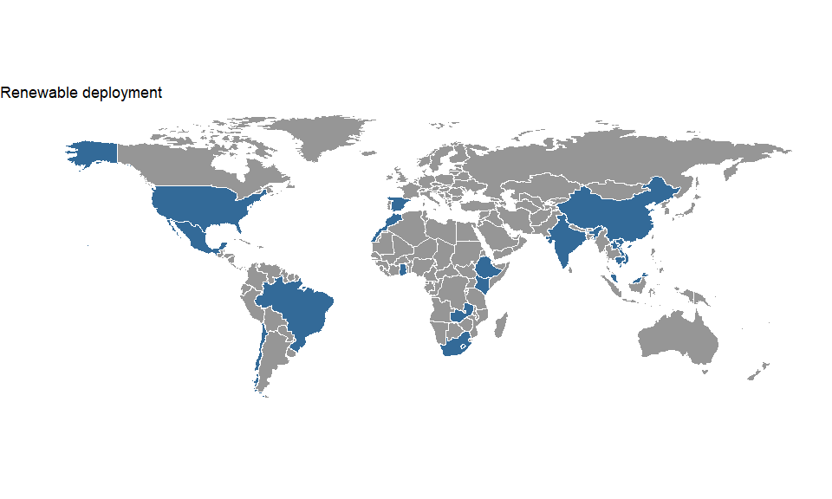

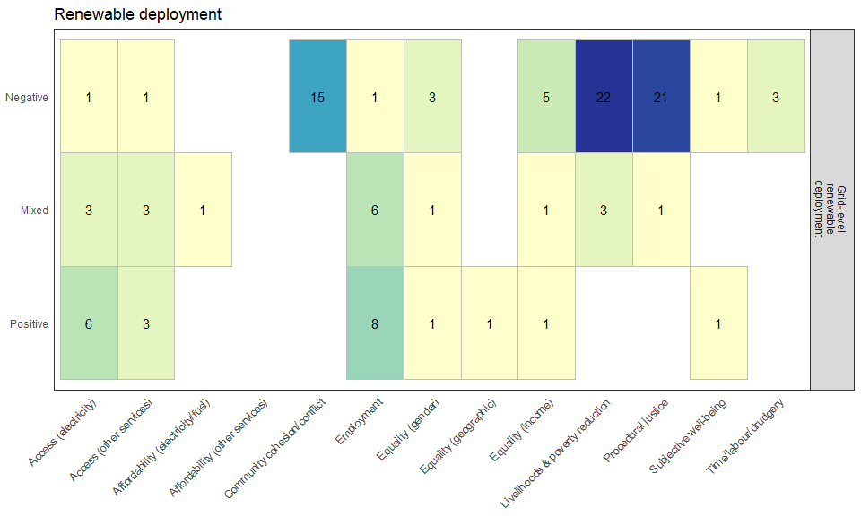

*Overview*

Grid-level renewable planning and deployment is the largest category of literature assessed, with 44 studies set across x countries. These studies can be distinguished from other policy categories in several ways.

First, they specifically focus on centralised renewable energy projects designed for export to the electricity grid, in contrast to more decentralised projects that deliver electricity mainly for own use (several of the latter are reported in the direct provisioning and subsidy categories). Second, these studies tend to have a highly localised focus, using mainly qualitative case study designs (e.g. interviews, surveys) to trace the social impacts of large and small renewable energy projects in their immediate vicinity. Third, there is a high coverage of countries in the global South, particularly South Asia (India, Vietnam, Laos, and Cambodia). This is due to the burgeoning literature on large hydropower dam projects, many of which are situated in this region and have been extensively studied. Indeed, hydropower dam projects account for over half of the assessed literature here (24 studies), followed by wind farm projects (11).[4] And finally, this literature tends to focus on livelihoods and poverty, procedural justice, community cohesion, and employment as social outcomes, in contrast to the distributional issues that are more prominent in other policy categories.

*Climate outcomes*

The climate outcomes of renewable planning and deployment studies range from smaller projects with less than 100 MW of installed capacity, to mega-projects of over 1000 MW, such as the Son La (2400 MW), Bakun (2400 MW) and Nam Theun 2 (1070 MW) hydropower dams (Cooke *et al* 2017, Manorom *et al* 2017, Hang Bui and Schreinemachers 2018). Some wind power projects also sit towards the higher end of this scale, such as the aggregate installed wind capacity of the Isthmus of Tehuantepec, Mexico (2317 MW), or the large wind farm at Lake Turkana, Kenya (310 MW) (Huesca-Pérez *et al* 2016, Cormack and Kurewa 2018).

Despite the individual, often privately financed nature of these projects, they all bear the fingerprint of policymaking. Large renewable energy installations often feature in wider national or regional strategic development plans. For instance, the Bakun dam is a component of the Sarawak Corridor of Renewable Energy (Malaysia), a complex regional investment and development plan for the island of Borneo (Sovacool and Bulan 2012). Similarly, the Nam Theun 2 dam, which exports electricity to Thailand, is one of the primary foreign exchange and revenue sources for the Laos government (Manorom *et al* 2017, Baird *et al* 2015). Multiple projects are also reported to be financed by international institutions, including the Asian Development Bank, the African Development Bank and the World Bank (Baird *et al* 2015, Cormack and Kurewa 2018, Blake and Barney 2018). In the case of smaller projects, many are dependent on national policies (e.g. wind or solar subsidies), or on the Clean Development Mechanism (Lakhanpal 2019, Jumani *et al* 2017, Huesca-Pérez *et al* 2016). An assessment of the localised effects of grid-level renewable deployment therefore complements and overlaps with several other of the reviewed policy categories.

*Social outcomes*

Overall, the literature tends towards a negative assessment of social outcomes resulting from these projects. Of the 44 articles reviewed, a total of 22 negative effects on livelihoods and poverty were reported, as well as a further 3 mixed (positive and negative) effects. This highly negative assessment arises primarily from extensive research into involuntary resettlement policies linked to hydropower dam reservoir flooding. In such cases, compensation packages for resettled communities often fall significantly short of promises made prior to resettlement, with financial support being too meagre, or compensated landholdings being of inferior quality and location (REFS). Compounding this, traditional subsistence and income-generating practices using communal forests, rivers and land may become infeasible in the new landscapes rendered by dam construction, resulting in further uncompensated losses and costs for local communities (REFS).

Interestingly, new literatures have reported similar land related concerns arising from large wind energy projects. In the Isthmus of Tehuantepec (Mexico), Lake Turkana (Kenya), and the Western Ghats (India) it is claimed that wind energy investors took advantage of weak regulatory contexts to minimise compliance costs or inadequately compensate rural landowners (Avila-Calero 2017, Cormack and Kurewa 2018, Huesca-Pérez *et al* 2016, Lakhanpal 2019). The siting of renewable energy infrastructures in rural, poor and indigenous areas has been linked to contemporary forms of enclosure – the privatisation of land previously held in communal ownership (Avila-Calero 2017, Cormack and Kurewa 2018, Obour *et al* 2016, Cooke *et al* 2017). These land enclosures can initiate new social conflicts as beneficiaries (and losers) emerge from the changing ownership and legal status of land resources, often superimposed upon, and exacerbating, pre-existing social fractures such as income inequality, ethnic conflicts, or gender divides. Hence we also see additional negative effects reported for issues such as community cohesion (x), income inequality (x) and gender inequality (x) as local societies adjust to significant disruption in their social, economic and geographic circumstances.

Many of the reviewed projects failed to achieve procedural justice (21 negative effects reported). Typically this outcome was linked to inadequate consultation by authorities and private companies regarding energy installations and their impacts (REFS). In one instance, locals only found out about a major hydropower dam when the machines arrived (Buechler *et al* 2016). Yet beyond mere consultation, communities desire to take part in the governance and design of a project, to draw benefits from it, or at minimum, to have reciprocal channels for lodging complaints and concerns. In many cases these options were absent and serious violations of procedural justice took place. The severe power imbalances between large renewable energy investors and local communities are key to understanding this outcome, particularly where regulatory contexts are weak and corrupt (Buechler *et al* 2016, Singer and Watanabe 2014), or where autocratic governance regimes offer no recourse for democratic decision making (Rousseau *et al* 2017, Baird *et al* 2015, Blake and Barney 2018).

On the positive side, several studies have reported improvements in employment opportunities (8 effects), particularly during the construction phase of large projects. Renewable energy projects are also an opportunity to provision electricity access in rural locations, as well as revitalise local infrastructures such as roads, schools and hospitals. Indeed such effects have been reported (Pheakdey 2017, Cooke *et al* 2017, Sivongxay *et al* 2017, Singer and Watanabe 2014). Equally, however, some studies report instances where villages are still waiting for electricity access, or have lost access to key services such as clean water (Urban *et al* 2015, Annys *et al* 2019, Jumani *et al* 2017, Baird *et al* 2015).

Overall, the poor social performance of grid-level renewable projects serves as a warning for the future development of large energy infrastructures, particularly in the global South where the vast majority of these effects have been recorded.

## Other

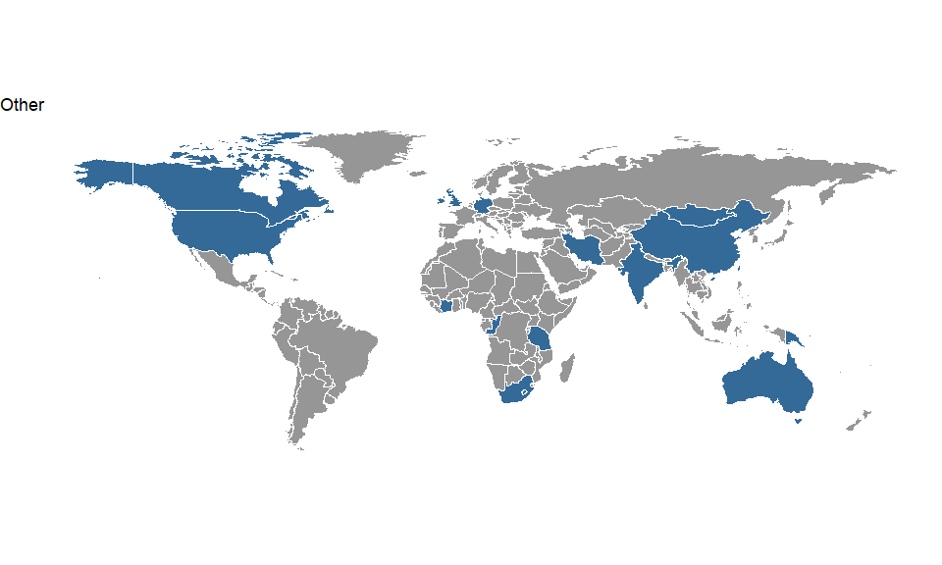

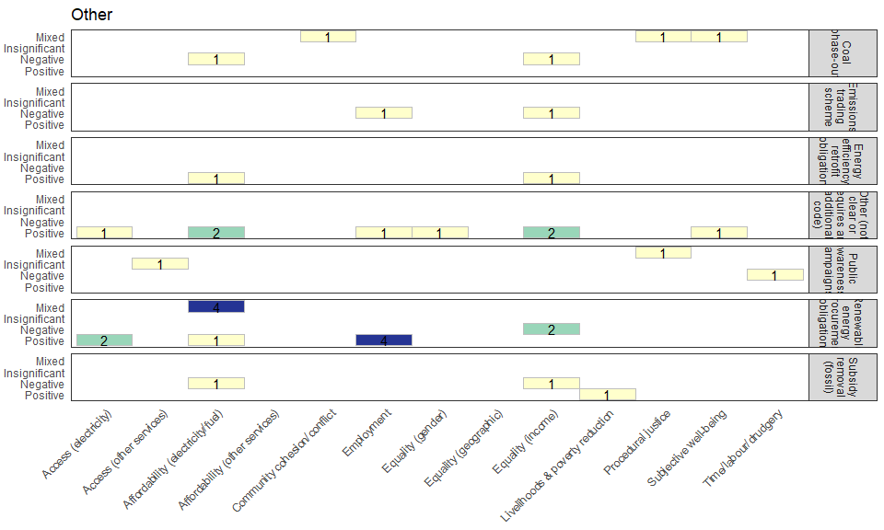

This final category is the most general, being comprised of 16 studies covering a wide range of policy types, including renewable energy procurement obligations (8), energy efficiency retrofit obligations (2), emissions trading schemes (2), public awareness campaigns (1), coal phase-out (1), subsidy removal for fossil fuels (1) and smart grid investment (1). The geographical coverage was large too, including countries from North America, Europe, Africa and Asia. However, the gap in Central and South America is still present in this category. All the policies in this category had been implemented since the turn of the century.

The regulatory interventions in this category (i.e. renewable energy procurement, energy efficiency retrofit obligations), as well as the direct government investment in smart grids, had largely positive effects in relation to affordability and access to energy, employment and equality. A common thread in explaining the positive social outcomes of these policies was the clear regulatory aims. For instance, the renewable energy procurement obligations that had positive effects on employment in the United States (Yi, 2013; Lee, 2017), led to more green jobs precisely because there was an obligation to increase the proportion of renewable energy procured by utilities. In South Africa (Pahle et al., 2016), this effect is even more noticeable because the procurement obligation was complemented by including *local* provisioning of jobs in the regulation itself. Similarly, the renewable energy procurement and energy efficiency retrofit regulatory policies that had a positive effect on access to and/or affordability of energy (in South Africa see Azimoh et al., 2015; in Mongolia see Sovacool et al., 2011; in Austrailia see Cludius et al., 2014; in Ireland see Farrell & Lyons, 2015; in India see Palit et al., 2013; and in the UK see Elsharkawy & Rutherford, 2018) and on equality (in the US see Bruegge et al., 2019; Zhou and Noonan, 2019), all shared clear regulatory aims, with several of the authors aurguing that, had the obligations been accompanied by complementary social goals and interventions (such as redistributive policies), their positive outcomes could have been greater.

The other policies covered in this category can be broadly grouped as economic and planning (i.e. subsidy removal, coal phase-out and emissions trading schemes) and information policies (public awareness campaign). These were all coded as having negative social outcomes in relation to affordability of energy, employment, equality and time use. These negative social outcomes seem to have been the result of unexpected effects, for example when the market or individuals were left to regulate the social outcomes of the policies, or a lack of accompanying interventions to reduce the negative distributional effects. Examples of the latter are the coal phase-out from home use in Beijing (Barrington-Leigh et al., 2019), where many households where unable to switch to other energy sources; and the subsidy removal for household fossil fuels in Iran (Kafaie & Garshasbi, 2016), where government cash payments did not compensate sufficiently for increases in the cost of living. In the case of the EU emissions trading schemes, the market mechanism implied that the price of the emission allowances bought by the (largely private) electricity companies was passed on to their consumers, rather than being a carbon scarcity rent that can be shared by all citizens (see the case of the EU in Branger et al., 2015). Similarly, companies used the emissions trading scheme in Quebec to reduce employment (i.e. scale) in a higher proportion than the reduction of carbon intensity would imply (see Hanoteau & Talbot, 2019). Finally, the public awareness campaign in Taiwan (Wang, 2016) had the effect of increasing women’s burdens and exacerbating women’s inequality.

## Discussion and Conclusion

Overall, despite the imperative that climate policy result in strong positive social outcomes wherever possible, that it address issues of poverty, equity, employment, and justice (to name a few), the evaluation of the social goals as positive, negative or mixed depends to a great extent on the expectations of the studies’ authors. In other words, it may be more about the research design choices made by scientists rather than easily discernible trends within the literature. While the environmental goals of the evaluated policies are clearly articulated (contributions to climate protection), authors hold different expectations on whether climate policies are supposed to have positive social effects or whether it is enough not to worsen (i.e. fail to alleviate) existing social problems. Given this variance in expectations, similar policies were evaluated differently by the studies and the cases were evaluated against different sets of social criteria (e.g. geographic equality, gender equality). It is likely that the studies only covered social criteria which show, depending on the case, clearly positive or clearly negative evaluations or criteria for which the studies are expected to highlight promising reform options. For these reasons and to ensure comparability of studies, it would be desirable to have a common standard set of social criteria. Developing this standard in detail could be a promising task for further research.

Many of the negative social outcomes identified in our review can be thought of as being associated with policy-makers failing to commit or attend to or fully achieve a ‘just transition’. Most basically, the idea of a ‘just transition’ refers to “the need to ensure that efforts to steer society towards a lower carbon future are underpinned by attention to issues of equity and justice” (Newell and Mulvaney, 2013: 132). For instance, by simultaneously addressing energy poverty alongside emissions reductions, or focusing on the plight of those whose livelihoods depend on the fossil fuel economy. In other words, it directly draws attention to the need to avoid the potential negative social outcomes of climate policy. There are both distributive and procedural issues raised by our analysis. Regarding the distributive aspects of ‘just transitions’ our analysis suggests a number of lessons… On the procedural side, many of the negative social outcomes we observe revolve around a lack of scope for citizen, community or public participation in decision-making. A lack of procedural justice in decision-making has long been acknowledged as a key reason underpinning public opposition to certain forms of climate policy interventions, especially renewable energy deployment (Upreti and van der Horst, 2004, Zoellner et al., 2008), and as a result many authors have argued that greater and more meaningful participation can lead to more publicly acceptable projects (Hall et al., 2013). The importance of meaningful participation leading to actual influence over decision-making is often stressed because public participation that becomes a mere ‘box-ticking’ exercise without scope for meaningful influence is likely to itself become a source of public resentment and policy failure (Lee et al., 2012). There is often an implicit assumption that greater procedural justice will necessarily lead to greater public acceptance of projects, however, of course, although neglected in the literature, under certain circumstances greater community involvement and influence may lead to project refusal. Addressing this issue may require participation further ‘upstream’ (i.e. on broader questions of the purpose and direction of policy rather than project siting, see Wilsdon and Willis, 2004). Efforts to shape policy at this wider, more systematic level with public values (e.g. Demski et al., 2015) offers a possible avenue through which to avoid public rejection of climate policy further ‘downstream’.

Moreover, we were struck by the fairly small number of studies meeting our selection criteria. There were a relatively low number of overall studies, reaching about 20 per year on average, within our sample. This may be a lower estimate but it also reflects the predominant focus of the literature on ex-ante modelling studies, as well as a limited (but currently growing) attention in the climate policy literature on broader dimensions of human well-being.

Finally, it was striking that, with a few exceptions (such as studies looking at off-grid solar or hydropower), most climate outcomes research remains focused on WEIRD countries, case studies, and populations: oriented to Western, Educated, Industrialized, Rich, and Democratic locations (Henrich *et al* 2010). Unfortunately, such WEIRD research samples from an overly thin slice of humanity, and yet researchers may assume their findings are universal. It focuses obsessively on industrialized societies, but fewer small-scale or agrarian societies where many of the world’s poor reside; it focuses on Western cultures, but not the rich mosaic of non-Western cultures that shape the beliefs and lives of more than half the world’s population. Finally, WEIRD research often oversamples “typical” populations—white, middleclass, middle age men or women, for example—but not “atypical” types such as the disabled, ethnic minorities, the poor, the old, or the young. This narrowness in populations may cause researchers to miss important dimensions of variation, and devote undue attention to analytical tendencies that are truly unusual in a global context.

Despite these caveats and complexities, however, there is ample evidence within our review that low-carbon policies and efforts, at a variety of scales and configurations, from taxes and FITs to subsidies and direct procurement, *can* when designed and implemented well meet the goals of climate mitigation and improvements in livelihood, reductions of poverty, enhancements of income, and the provision of employment and community cohesion. Although the range and scope of these connections was not always strong or straightforward, it does nonetheless imply that low-carbon goals can be inherently compatible with more equitable, cohesive, fairier societies and cultures.

Aldy J E 2014 The crucial role of policy surveillance in international climate policy *Clim. Change* **126** 279–92

Alkire S 2002 Dimensions of human development *World Dev.* **30** 181–205

Allen M, Babiker M, Chen Y, Coninck H de, Connors S, Diemen R van, Dube O P, Ebi K, Engelbrecht F, Ferrat M, Ford J, Forster P, Fuss S, Guillen T, Harold J, Hoegh-Guldberg O, Hourcade J-C, Huppmann D, Jacob D, Jiang K, Johansen T G, Kainuma M, Kleijne K de, Kriegler E, Ley D, Liverman D, Mahowald N, Masson-Delmotte V, Matthews R, Melcher R, Millar R, Mintenbeck K, Morelli A, Moufouma-Okia W, Mundaca L, Nicolai M, Okereke C, Pathak M, Payne A, Pidcock R, Pirani A, Poloczanska E, Pörtner H-O, Revi A, Riahi K, Roberts D C, Rogelj J, Roy J, Seneviratne S, Shukla P R, Skea J, Slade R, Shindell D, Singh C, Solecki W, Steg L, Taylor M, Tschakert P, Waisman H, Warren R, Zhai P and Zickfeld K 2018 Summary for Policymakers *Global Warming of 1.5oC: an IPCC special report on the impacts of global warming of 1.5oC above pre-industrial levels and related global greenhouse gas emissions pathways, in the context of strengthening the global response to the threat of climate change* (Cambridge University Press)

Andor M A, Frondel M and Sommer S 2018 Equity and the willingness to pay for green electricity in Germany *Nat. Energy* **3** 876–81

Annys S, Adgo E, Ghebreyohannes T, Van Passel S, Dessein J and Nyssen J 2019 Impacts of the hydropower-controlled Tana-Beles interbasin water transfer on downstream rural livelihoods (northwest Ethiopia) *J. Hydrol.* **569** 436–48

Avila-Calero S 2017 Contesting energy transitions: wind power and conflicts in the Isthmus of Tehuantepec *J. Polit. Ecol.* **24** 992

Azimoh C L, Klintenberg P, Mbohwa C and Wallin F 2017 Replicability and scalability of mini-grid solution to rural electrification programs in sub-Saharan Africa *Renew. Energy* **106** 222–31

Baird I G, Shoemaker B P and Manorom K 2015 The People and their River, the World Bank and its Dam: Revisiting the Xe Bang Fai River in Laos *Dev. Change* **46** 1080–105

Barbier E B 2014 Climate change mitigation policies and poverty *Wiley Interdiscip. Rev. Clim. Chang.* **5** 483–91

Barrington-Leigh C, Baumgartner J, Carter E, Robinson B E, Tao S and Zhang Y 2019 An evaluation of air quality, home heating and well-being under Beijing’s programme to eliminate household coal use *Nat. Energy* **4** 416–23 Online: http://dx.doi.org/10.1038/s41560-019-0386-2

Bates S, Clapton J and Coren E 2007 Systematic maps to support the evidence base in social care *Evid. Policy* **3** 539–51

Bendlin L 2014 Women’s human rights in a changing climate: highlighting the distributive effects of climate policies *Cambridge Rev. Int. Aff.* **27** 680–98

Blake D J H and Barney K 2018 Structural Injustice, Slow Violence? The Political Ecology of a “Best Practice” Hydropower Dam in Lao PDR *J. Contemp. Asia* **48** 808–34 Online: https://doi.org/10.1080/00472336.2018.1482560

Bouzarovski S and Petrova S 2015 A global perspective on domestic energy deprivation: Overcoming the energy poverty-fuel poverty binary *Energy Res. Soc. Sci.*

Brand-Correa L I and Steinberger J K 2017 A framework for decoupling human need satisfaction from energy use *Ecol. Econ.* **141** 43–52 Online: http://dx.doi.org/10.1016/j.ecolecon.2017.05.019

Buechler S, Sen D, Khandekar N and Scott C A 2016 Re-linking governance of energy with livelihoods and irrigation in Uttarakhand, India *Water* **8** 1–22

Burney J A 2020 The downstream air pollution impacts of the transition from coal to natural gas in the United States *Nat. Sustain.* Online: http://dx.doi.org/10.1038/s41893-019-0453-5

Cameron C, Pachauri S, Rao N D, Mccollum D, Rogelj J and Riahi K 2016 Policy trade-offs between climate mitigation and clean cook-stove access in South Asia *Nat. Energy* **1** 1–5

Camprubí L, Malmusi D, Mehdipanah R, Palència L, Molnar A, Muntaner C and Borrell C 2016 Façade insulation retrofitting policy implementation process and its effects on health equity determinants: A realist review *Energy Policy*

Carley S, Evans T P, Graff M and Konisky D M 2018 A framework for evaluating geographic disparities in energy transition vulnerability *Nat. Energy* Online: http://www.nature.com/articles/s41560-018-0142-z

Castro M C, Krieger G R, Balge M Z, Tanner M, Utzinger J, Whittaker M and Singer B H 2016 Examples of coupled human and environmental systems from the extractive industry and hydropower sector interfaces *Proc. Natl. Acad. Sci. U. S. A.* **113** 14528–35

Cherni J A and Hill Y 2009 Energy and policy providing for sustainable rural livelihoods in remote locations - The case of Cuba *Geoforum* **40** 645–54

Cooke F M, Nordensvard J, Saat G Bin, Urban F and Siciliano G 2017 The Limits of Social Protection: The Case of Hydropower Dams and Indigenous Peoples’ Land *Asia Pacific Policy Stud.* **4** 437–50

Cormack Z and Kurewa A 2018 The changing value of land in Northern Kenya: the case of Lake Turkana Wind Power *Crit. African Stud.* **10** 89–107 Online: https://doi.org/10.1080/21681392.2018.1470017

Costanza R, Kubiszewski I, Lovins H, McGlade J, Pickett K E, Ragnarsdottir K V, Roberts D, Vogli R De and Wilkinson R 2014 Time to leave GDP behind *Nature* **505** 283–5

Curry C, Cherni J A and Mapako M 2017 The potential and reality of the solar water heater programme in South African townships: Lessons from the City of Tshwane *Energy Policy* **106** 75–84

Douenne T and Fabre A 2020 French attitudes on climate change, carbon taxation and other climate policies *Ecol. Econ.* **169**

Doyal L and Gough I 1991 *A Theory of Human Need* (London: Macmillan)

Fleurbaey M, Kartha S, Bolwig S, Chee Y L, Chen Y, Corbera E, Lecocq F, Lutz W, Muylaert M S, Norgaard R B, Okereke C and Sagar A 2014 Sustainable Development and Equity *Climate Change 2014: Mitigation of Climate Change. Working Group III Contribution to the Fifth Assessment Report of the Intergovernmental Panel on Climate Change* ed O Edenhofer, R Pichs-Madruga, Y Sokona, E Farahani, S Kadner, K Seyboth, A Adler, I Baum, S Brunner, P Eickemeier, B Kriemann, J Savolainen, S Schlomer, C von Stechow, T Zwickel and J C Minx (Cambridge, United Kingdom and New York, NY, USA: Cambridge University Press)

Galvin R 2019 Letting the Gini out of the fuel poverty bottle? Correlating cold homes and income inequality in European Union countries *Energy Res. Soc. Sci.*

Gough I 2015 Climate Change and Sustainable Welfare : An Argument for the Centrality of Human Needs *Cambridge J. Econ.* **39** 1191–214

Green D 2004 Thailand’s solar white elephants: An analysis of 15yr of solar battery charging programmes in northern Thailand *Energy Policy* **32** 747–60

Grey C N B, Schmieder-Gaite T, Jiang S, Nascimento C and Poortinga W 2017 Cold homes, fuel poverty and energy efficiency improvements: A longitudinal focus group approach. *Indoor + built Environ. J. Int. Soc. Built Environ.* **26** 902–13

Haddaway N R, Bernes C, Jonsson B G and Hedlund K 2016 The benefits of systematic mapping to evidence-based environmental management *Ambio* **45** 613–20

Haddaway N R and Macura B 2018 The role of reporting standards in producing robust literature reviews *Nat. Clim. Chang.* **8** 444–453 Online: https://doi.org/10.1038/s41558-018-0180-3.

Haddaway N R, Macura B, Whaley P and Pullin A S 2018 ROSES RepOrting standards for Systematic Evidence Syntheses: pro forma, flow-diagram and descriptive summary of the plan and conduct of environmental systematic reviews and systematic maps *Environ. Evid.* **7** 1–8 Online: https://doi.org/10.1186/s13750-018-0121-7

Hang Bui T M and Schreinemachers P 2018 Livelihood changes of affected households under resource scarcity: The Son La hydropower project in Vietnam *Kasetsart J. Soc. Sci.*

Heffron R J and McCauley D 2018 What is the ‘Just Transition’? *Geoforum*

Henrich J, Heine S J and Norenzayan A 2010 Most people are not WEIRD *Nature* **466** 29

Huesca-Pérez M E, Sheinbaum-Pardo C and Köppel J 2016 Social implications of siting wind energy in a disadvantaged region - The case of the Isthmus of Tehuantepec, Mexico *Renew. Sustain. Energy Rev.* **58** 952–65

Jakob M, Chen C, Fuss S, Marxen A, Rao N D and Edenhofer O 2016 Carbon Pricing Revenues Could Close Infrastructure Access Gaps *World Dev.* **84** 254–65 Online: http://dx.doi.org/10.1016/j.worlddev.2016.03.001

James K L, Randall N P and Haddaway N R 2016 A methodology for systematic mapping in environmental sciences *Environ. Evid.* **5** 1–13

Jumani S, Rao S, Machado S and Prakash A 2017 Big concerns with small projects: Evaluating the socio-ecological impacts of small hydropower projects in India *Ambio* **46** 500–11

Klinsky S, Roberts T, Huq S, Okereke C, Newell P, Dauvergne P, O’Brien K, Schroeder H, Tschakert P, Clapp J, Keck M, Biermann F, Liverman D, Gupta J, Rahman A, Messner D, Pellow D and Bauer S 2016 Why equity is fundamental in climate change policy research *Glob. Environ. Chang.* **44** 170–3 Online: http://linkinghub.elsevier.com/retrieve/pii/S0959378016301285

Klinsky S and Winkler H 2018 Building equity in: strategies for integrating equity into modelling for a 1.5°C world *Philos. Trans. A. Math. Phys. Eng. Sci.* **376**

Kwan S C and Hashim J H 2016 A review on co-benefits of mass public transportation in climate change mitigation *Sustain. Cities Soc.* **22** 11–8 Online: http://dx.doi.org/10.1016/j.scs.2016.01.004

Lakhanpal S 2019 Contesting renewable energy in the global south: A case-study of local opposition to a wind power project in the Western Ghats of India *Environ. Dev.* **30** 51–60

Lamb W F and Steinberger J K 2017 Human well-being and climate change mitigation *Wiley Interdiscip. Rev. Clim. Chang.* **8** 1–16

Lockwood M 2018 Right-wing populism and the climate change agenda: exploring the linkages *Env. Polit.* **27** 1–21 Online: https://doi.org/10.1080/09644016.2018.1458411

Maestre-Andrés S, Drews S and van den Bergh J 2019 Perceived fairness and public acceptability of carbon pricing: a review of the literature *Clim. Policy* **19** 1186–204

Mahat I 2011 Gender, energy, and empowerment: a case study of the Rural Energy Development Program in Nepal *Dev. Pract.* **21** 405–20

Mahat I 2006 Gender and rural energy technologies: Empowerment perspective - A case study of Nepal *Can. J. Dev. Stud.* **27** 531–50

Maidment C D, Jones C R, Webb T L, Hathway E A and Gilbertson J M 2014 The impact of household energy efficiency measures on health: A meta-analysis *Energy Policy*

Manorom K, Baird I G and Shoemaker B 2017 The World Bank, Hydropower-based Poverty Alleviation and Indigenous Peoples: On-the-Ground Realities in the Xe Bang Fai River Basin of Laos *Forum Dev. Stud.* **44** 275–300

Markkanen S and Anger-Kraavi A 2019 Social impacts of climate change mitigation policies and their implications for inequality *Clim. Policy* Online: https://www.tandfonline.com/doi/full/10.1080/14693062.2019.1596873

Mattioli G 2016 Transport needs in a climate-constrained world. A novel framework to reconcile social and environmental sustainability in transport *Energy Res. Soc. Sci.* **18** 118–28 Online: http://dx.doi.org/10.1016/j.erss.2016.03.025

Mayrhofer J P and Gupta J 2016 The science and politics of co-benefits in climate policy *Environ. Sci. Policy* **57** 22–30

Minx J C, Callaghan M, Lamb W F, Garard J and Edenhofer O 2017 Learning about climate change solutions in the IPCC and beyond *Environ. Sci. Policy* **77**

Newell P and Mulvaney D 2013 The political economy of the “just transition” *Geogr. J.* **179** 132–40

Nussbaum M 2003 Capabilities As Fundamental Entitlements: Sen and Social Justice *Fem. Econ.* **9** 33–59 Online: http://www.tandfonline.com/doi/abs/10.1080/1354570022000077926

O’Mara-Eves A, Thomas J, McNaught J, Miwa M and Ananiadou S 2015 Using text mining for study identification in systematic reviews: a systematic review of current approaches *Syst. Rev.* **4** 59 Online: http://systematicreviewsjournal.biomedcentral.com/articles/10.1186/s13643-015-0031-5

O’Neill D W, Fanning A L, Lamb W F and Steinberger J K 2018 A good life for all within planetary boundaries *Nat. Sustain.* **1** 88–95

Obour P B, Owusu K, Agyeman E A, Ahenkan A and Madrid À N 2016 The impacts of dams on local livelihoods: a study of the Bui Hydroelectric Project in Ghana *Int. J. Water Resour. Dev.* **32** 286–300 Online: http://dx.doi.org/10.1080/07900627.2015.1022892

Ohlendorf N, Jakob M, Minx J C, Schröder C and Steckel J C 2018 *Distributional Impacts of Climate Mitigation Policies - A Meta-Analysis* (Berlin)

Pedregosa F, Gramfort A, Michel V, Thirion B, Grisel O, Blondel M, Prettenhofer P, Dubourg V, Pedregosa F, Gramfort A, Michel V, Thirion B, Pedregosa F and Weiss R 2011 Scikit-learn: Machine Learning in Python *J. Mach. Learn. Res.* **12** 2825–30

Pheakdey H 2017 Hydropower and local community: A case study of the Kamchay dam, a China-funded hydropower project in Cambodia *Community Dev.* **48** 385–402 Online: http://dx.doi.org/10.1080/15575330.2017.1304432

Policies and Operations Evaluation Department (IOB) 2013 *Renewable Energy: Access and Impact* (The Hague) Online: https://www.government.nl/documents/reports/2013/03/01/iob-study-renewable-energy-access-and-impact

Pope D, Bruce N, Dherani M, Jagoe K and Rehfuess E 2017 Real-life effectiveness of ‘improved’ stoves and clean fuels in reducing PM 2.5 and CO: Systematic review and meta-analysis *Environ. Int.*

Raha D, Mahanta P and Clarke M L 2014 The implementation of decentralised biogas plants in Assam, NE India: The impact and effectiveness of the National Biogas and Manure Management Programme *Energy Policy* **68** 80–91

Rao N D, van Ruijven B J, Riahi K and Bosetti V 2017 Improving poverty and inequality modelling in climate research *Nat. Clim. Chang.* **7** 857–62 Online: http://dx.doi.org/10.1038/s41558-017-0004-x

Riggert J, Hall N, Reed J and Oh A 2000 Non-energy benefits of weatherization and low-income residential programs: The 1999 mega-meta-study *Proc. ACEEE Summer Study Energy Effic. Build.* **8**

Rodríguez-Pose A 2018 The revenge of the places that don’t matter (and what to do about it) *Cambridge J. Reg. Econ. Soc.* **11** 189–209

Rousseau J F, Orange D, Habich-Sobiegalla S and Van Thiet N 2017 Socialist hydropower governances compared: dams and resettlement as experienced by Dai and Thai societies from the Sino-Vietnamese borderlands *Reg. Environ. Chang.* **17** 2409–19

Roy J, Tschakert P, Waisman H, Halim S A, Antwi-Agyei P, Dasgupta P, Hayward B, Kanninen M, Liverman D, Okereke C, Pinho P F, Riahi K and Suarez Rodriguez A G 2018 Sustainable Development, Poverty Eradication and Reducing Inequalities *Global Warming of 1.5°C. An IPCC Special Report on the impacts of global warming of 1.5°C above pre-industrial levels and related global greenhouse gas emission pathways, in the context of strengthening the global response to the threat of climate change,* ed V Masson-Delmotte, P Zhai, H-O Pörtner, D Roberts, J Skea, P R Shukla, A Pirani, W Moufouma-Okia, C Péan, R Pidcock, S Connors, J B R Matthews, Y Chen, X Zhou, M I Gomis, E Lonnoy, T Maycock, M Tignor and T Waterfield (Cambridge, U.K.: Cambridge University Pres) pp 445–538 Online: https://www.ipcc.ch/site/assets/uploads/sites/2/2018/11/SR15_Chapter5_Low_Res-1.pdf

Schweitzer M and Tonn B 2003 Non-energy benefits of the US Weatherization Assistance Program: A summary of their scope and magnitude *Appl. Energy* **76** 321–35

Sen A 1999 *Development as Freedom* (Oxford: Oxford University Press)

Seyfang G, Park J J and Smith A 2013 A thousand flowers blooming? An examination of community energy in the UK *Energy Policy*

Shortt N and Rugkåsa J 2007 “The walls were so damp and cold” fuel poverty and ill health in Northern Ireland: Results from a housing intervention *Heal. Place* **13** 99–110

Singer J and Watanabe T 2014 Reducing reservoir impacts and improving outcomes for dam-forced resettlement: Experiences in central Vietnam *Lakes Reserv. Res. Manag.* **19** 225–35

Sivongxay A, Greiner R and Garnett S T 2017 Livelihood impacts of hydropower projects on downstream communities in central laos and mitigation measures *Water Resour. Rural Dev.*

Smith K R and Haigler E 2008 Co-Benefits of Climate Mitigation and Health Protection in Energy Systems: Scoping Methods *Annu. Rev. Public Health* **29** 11–25

Somanthan E, Sterner T, Sugiyama T, Chimanikire D, Dubash N K, Essandoh-Yeddu J, Fifita S, Goulder L, Jaffe A, Labandeira X, Managi S, Mitchell C, Montero J P, Teng F and Zylicz T 2014 National and Sub-national Policies and Institutions *Climate Change 2014: Mitigation of Climate Change. Contribution of Working Group III to the Fifth Assessment Report of the Intergovernmental Panel on Climate Change* ed O Edenhofer, R Pichs-Madruga, Y Sokona, E Farahani, S Kadner, K Seyboth, A Adler, I Baum, S Brunner, P Eickemeier, B Kriemann, J Savolainen, S Schlomer, C von Stechow, T Zwickel and J C Minx (Cambridge, United Kingdom and New York, NY, USA: Cambridge University Press) pp 1141–206

Sorrell S 2007 Improving the evidence base for energy policy: The role of systematic reviews *Energy Policy* **35** 1858–71

Sovacool B K 2016 *Energy Access, Poverty, and Development* (Routledge)

Sovacool B K and Bulan L C 2012 Energy security and hydropower development in Malaysia: The drivers and challenges facing the Sarawak Corridor of Renewable Energy (SCORE) *Renew. Energy* **40** 113–29

Sovacool B K and Drupady I M 2011 Summoning earth and fire: The energy development implications of Grameen Shakti (GS) in Bangladesh *Energy* **36** 4445–59

Sovacool B K and Linnér B-O 2016 The Perils of Climate Diplomacy: The Political Economy of the UNFCCC *The Political Economy of Climate Change Adaptation* (London: Palgrave Macmillan UK) pp 110–35

Sovacool B K, Martiskainen M, Hook A and Baker L 2020 Beyond cost and carbon: The multidimensional co-benefits of low carbon transitions in Europe *Ecol. Econ.* **169** 13–4

von Stechow C, McCollum D, Riahi K, Minx J C, Kriegler E, van Vuuren D P, Jewell J, Robledo-Abad C, Hertwich E, Tavoni M, Mirasgedis S, Lah O, Roy J, Mulugetta Y, Dubash N K, Bollen J, Ürge-Vorsatz D and Edenhofer O 2015 Integrating Global Climate Change Mitigation Goals with Other Sustainability Objectives: A Synthesis *Annu. Rev. Environ. Resour.* **40** 363–94 Online: http://www.annualreviews.org/doi/10.1146/annurev-environ-021113-095626

von Stechow C, Minx J C, Riahi K, Jewell J, McCollum D L, Callaghan M W, Bertram C, Luderer G and Baiocchi G 2016 2oC and the SDGs: United they stand, divided they fall? *Environ. Res. Lett.* **11**

Stiglitz J E, Sen A and Fitoussi J-P 2009 *Report by the Commission on the Measurement of Economic Performance and Social Progress* (Paris: Commission on the Measurement of Economic Performance and Social Progress) Online: http://www.stiglitz-sen-fitoussi.fr/documents/rapport_anglais.pdf

Svenningsen L S 2019 Social preferences for distributive outcomes of climate policy *Clim. Change* **157** 319–36

Thomson H, Thomas S, Sellstrom E and Petticrew M 2017 Housing improvements for health and associated socio-economic outcomes. *Cochrane database Syst. Rev.* **2**

Tonn B, Schmoyer R and Wagner S 2003 Weatherizing the homes of low-income home energy assistance program clients: A programmatic assessment *Energy Policy* **31** 735–44

UNEP 2018 *The Emissions Gap Report 2018* (Nairobi: United Nations Environment Program) Online: http://www.un.org/Depts/Cartographic/english/htmain.htm

United Nations General Assembly 2015 *Transforming our world: the 2030 Agenda for Sustainable Development* (New York, USA)

Urban F, Nordensvard J, Siciliano G and Li B 2015 Chinese Overseas Hydropower Dams and Social Sustainability: The Bui Dam in Ghana and the Kamchay Dam in Cambodia *Asia Pacific Policy Stud.* **2** 573–89

Ürge-Vorsatz D, Herrero S T, Dubash N K and Lecocq F 2014 Measuring the Co-Benefits of Climate Change Mitigation *Annu. Rev. Environ. Resour.* **39** 549–82

Watson P, Gabriel M and Rooney M 2015 Get bill smart: A community-partnership approach to supporting low-income households to achieve home energy savings *Indoor Built Environ.* **24** 867–77

Watts N, Amann M, Arnell N, Ayeb-Karlsson S, Belesova K, Boykoff M, Byass P, Cai W, Campbell-Lendrum D, Capstick S, Chambers J, Dalin C, Daly M, Dasandi N, Davies M, Drummond P, Dubrow R, Ebi K L, Eckelman M, Ekins P, Escobar L E, Fernandez Montoya L, Georgeson L, Graham H, Haggar P, Hamilton I, Hartinger S, Hess J, Kelman I, Kiesewetter G, Kjellstrom T, Kniveton D, Lemke B, Liu Y, Lott M, Lowe R, Sewe M O, Martinez-Urtaza J, Maslin M, McAllister L, McGushin A, Jankin Mikhaylov S, Milner J, Moradi-Lakeh M, Morrissey K, Murray K, Munzert S, Nilsson M, Neville T, Oreszczyn T, Owfi F, Pearman O, Pencheon D, Phung D, Pye S, Quinn R, Rabbaniha M, Robinson E, Rocklöv J, Semenza J C, Sherman J, Shumake-Guillemot J, Tabatabaei M, Taylor J, Trinanes J, Wilkinson P, Costello A, Gong P and Montgomery H 2019 The 2019 report of The Lancet Countdown on health and climate change: ensuring that the health of a child born today is not defined by a changing climate *Lancet* **394** 1836–78

Westgate M J, Haddaway N R, Cheng S H, McIntosh E J, Marshall C and Lindenmayer D B 2018 Software support for environmental evidence synthesis *Nat. Ecol. Evol.* **2** 588–90 Online: http://www.nature.com/articles/s41559-018-0502-x

Yushchenko A and Patel M K 2016 Contributing to a green energy economy? A macroeconomic analysis of an energy efficiency program operated by a Swiss utility *Appl. Energy* **179** 1304–20

1.
2. An optional 6th stage, a critical appraisal of the evidence, is not conducted in this review.
3. At an optimistic estimate of 30 seconds per abstract, screening ~40,000 articles would take a researcher over two months of full time work.
4. A reminder: in the scope of this review, we excluded studies that investigate the public acceptance of policies and projects. As a result, the large literature situated in northern Europe on public perceptions of wind power is not covered here.